

**C**omputer **Ar**chitecture

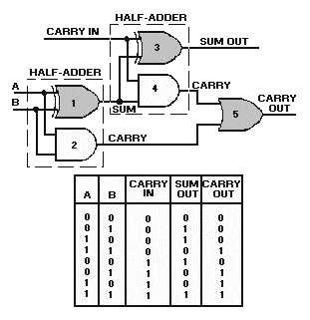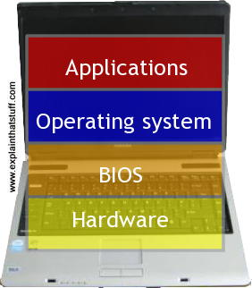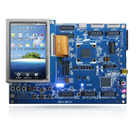

**CAR**

Logbook **PART 2**

ID: 769535

Practical Tutor: Ann Plummer

**- Table of Contents -**

Topic: Full Adders (term 2) 4

Topic: Karnaugh Maps 4-input with worked ex (term 2) 5

Topic: Karnaugh Maps 4-input with worked ex and X states (term 2) 6

Topic: Unix/Linux Cheat Sheet (term 2) 7

Topic: DOS Simple Guide and Cheat Sheet (term 2) 8

Topic: Advanced Unix/Linux 1 - 5 (term 2) 9

Topic: Advanced Unix/Linux extra ex's 1 - 2 (term 2) 12

Topic: Advanced Unix/Linux extra ex's 3 - 4 (term 2) 13

Topic: Memory Organization ex's 1 - 2 (term 2) 14

Topic: Memory Organization ex 3 (term 2) 14

Topic: Review Qs for Operating Systems (term 2) 15

Topic: Memory Management and Virtual Memory (term 2) 16

Topic: File Systems ex's 1 - 2 (term 2) 17

Topic: My Formative Test post mortem and Exam Revision (term 2) 21

Bibliography 23

Checklist 24

My Study Group (can change from Term 1)

Who is in your study group?

Complete below.

Put your name and email FIRST.

You can have up to 5 people in your group.

You must all be in the same practical group.

***If you would like help getting into a study group or changing groups, please ask your practical tutor***.

My Study Group

Matthew Hawkins

up769535@myport.ac.uk

Email:

@myport.ac.uk

Email:

@myport.ac.uk

Email:

@myport.ac.uk

Email:

@myport.ac.uk

Email:

It’s easy to create a new practical group (follow the instructions on Moodle) or email [ann.plummer@gmail.com](mailto:ann.plummer@gmail.com) with existing group changes.

With every exercise in your logbook, customize your answers with your name to help prevent others plagiarising your work.

You will need to get a minimum of 6 signoffs this term.

# Topic: Full Adders (term 2)

* The half-adder is extremely useful until you want to add more than one binary digit quantities. The slow way to develop a two binary digit adder would be to make a truth table and reduce it. Then when you decide to make a three binary digit adder, do it again, .......
* Create a full adder (one that will add 3 bits) from 2 half adders, in a simulator. Screenshot it in here (after putting your name somewhere on the circuit):

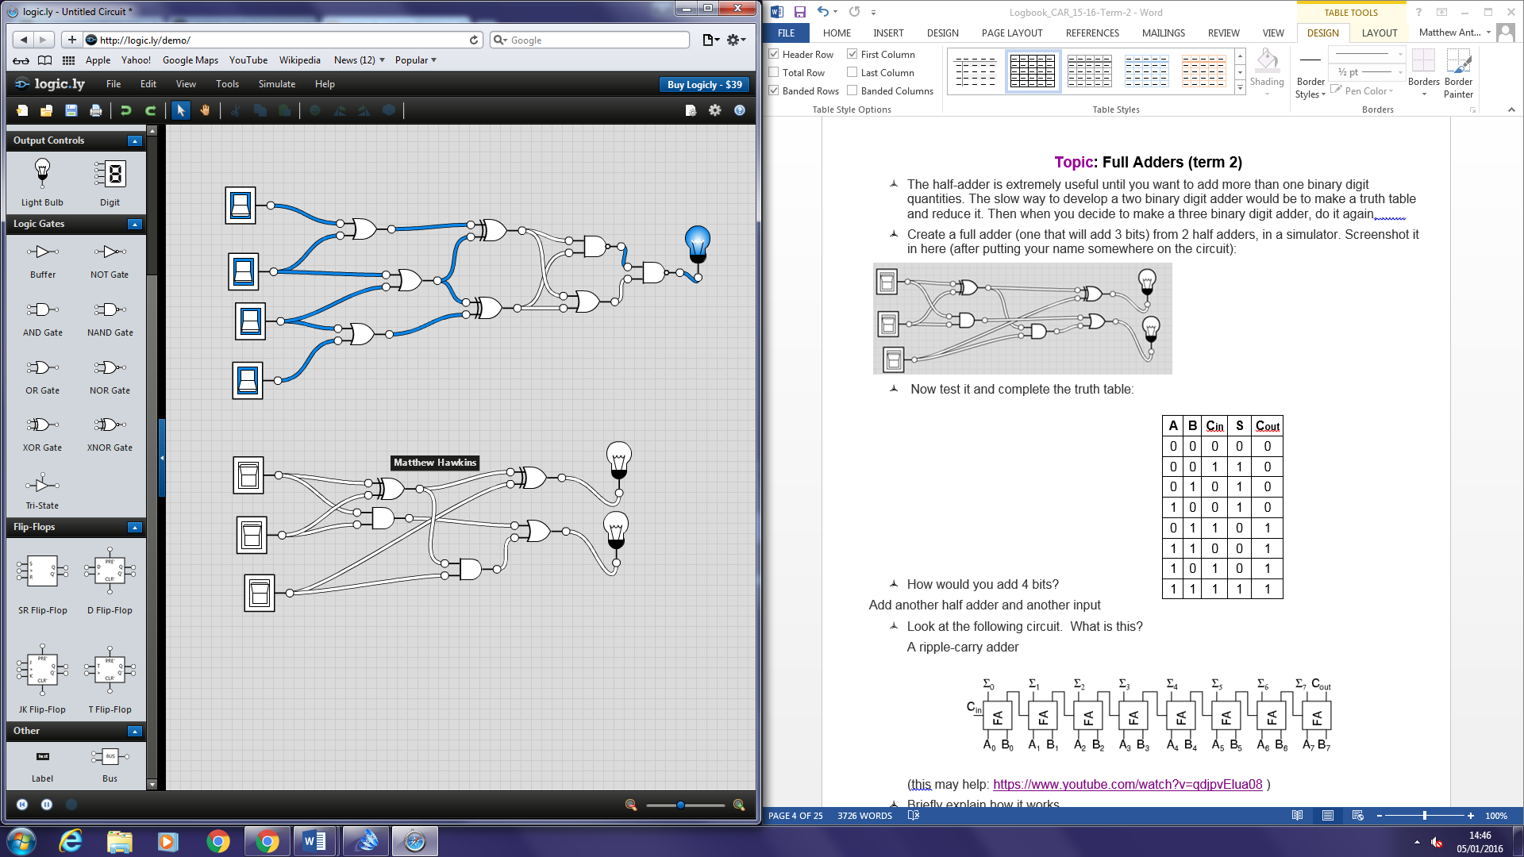

* Now test it and complete the truth table:

|  |  |  |  |  |
| --- | --- | --- | --- | --- |
| **A** | **B** | **Cin** | **S** | **Cout** |
| 0 | 0 | 0 | 0 | 0 |
| 0 | 0 | 1 | 1 | 0 |
| 0 | 1 | 0 | 1 | 0 |
| 1 | 0 | 0 | 1 | 0 |
| 0 | 1 | 1 | 0 | 1 |
| 1 | 1 | 0 | 0 | 1 |
| 1 | 0 | 1 | 0 | 1 |
| 1 | 1 | 1 | 1 | 1 |

* How would you add 4 bits?

Add another half adder and another input

* Look at the following circuit. What is this?

A ripple-carry adder

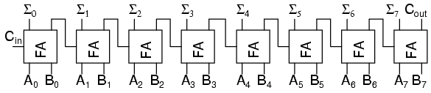

(this may help: <https://www.youtube.com/watch?v=qdjpvElua08> )

* Briefly explain how it works

Each full adder gets an input of Cin and then outputs a Cout. The Cout of each full adder is the Cin of the following adder. It is therefore called a ripple-carry adder as each bit carries over to the next full adder.

# Topic: Karnaugh Maps 4-input with worked ex (term 2)

* Create a circuit in <http://logic.ly/demo/> with 4 inputs, A, B, C, D; output F. Have *at least* **5** gates + 2 NOT gates in your circuit. Screenshot it here (after putting **your name** somewhere on the circuit):

|  |  |  |  |  |
| --- | --- | --- | --- | --- |
| **A** | **B** | **C** | **D** | **F** |
| 0 | 0 | 0 | 0 | 1 |
| 0 | 0 | 0 | 1 | 1 |
| 0 | 0 | 1 | 0 | 1 |
| 0 | 0 | 1 | 1 | 1 |
| 0 | 1 | 0 | 0 | 0 |
| 0 | 1 | 0 | 1 | 1 |
| 0 | 1 | 1 | 0 | 1 |
| 0 | 1 | 1 | 1 | 0 |
| 1 | 0 | 0 | 0 | 0 |
| 1 | 0 | 0 | 1 | 1 |
| 1 | 0 | 1 | 0 | 1 |
| 1 | 0 | 1 | 1 | 0 |
| 1 | 1 | 0 | 0 | 0 |
| 1 | 1 | 0 | 1 | 1 |
| 1 | 1 | 1 | 0 | 1 |
| 1 | 1 | 1 | 1 | 0 |

* Test it and complete a truth table:
* 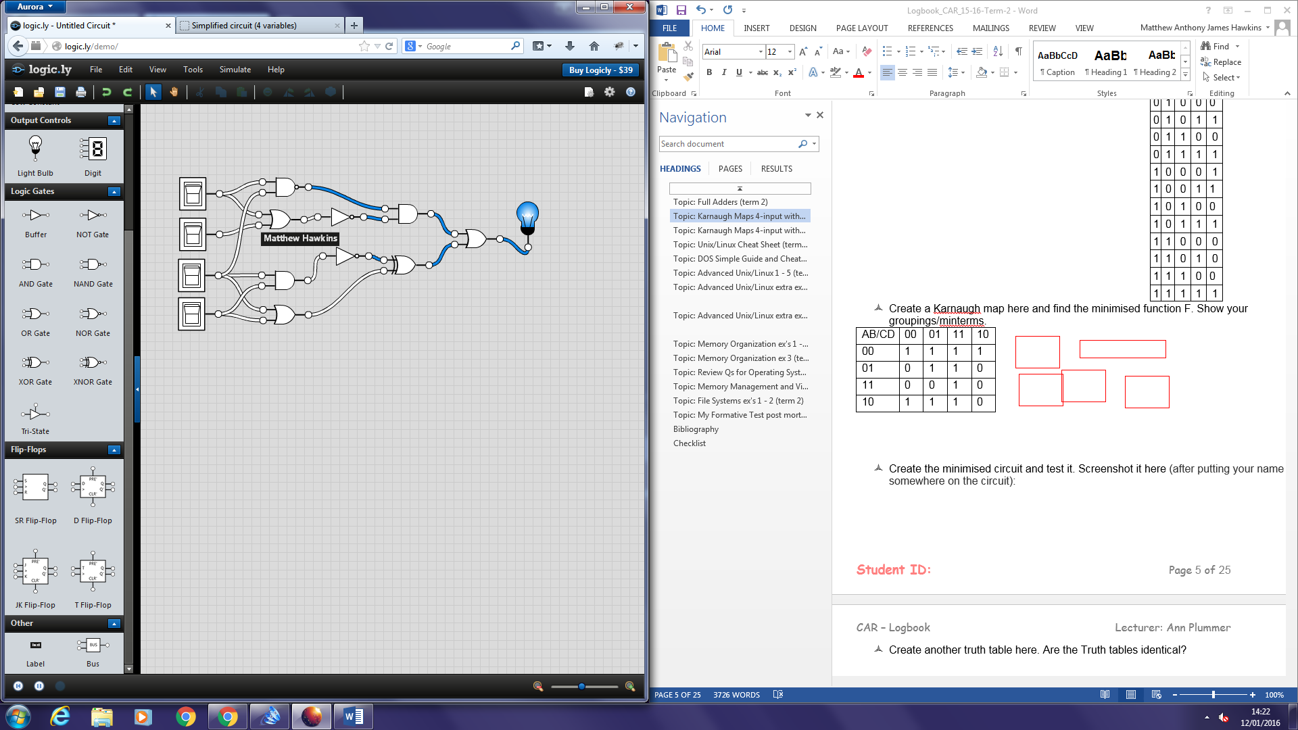
* Create a Karnaugh map here and find the minimised function F. Show your groupings/minterms.

|  |  |  |  |  |
| --- | --- | --- | --- | --- |
| AB/CD | 00 | 01 | 11 | 10 |
| 00 | 1 | 1 | 1 | 1 |
| 01 | 0 | 1 | 0 | 1 |
| 11 | 0 | 1 | 0 | 1 |
| 10 | 0 | 1 | 0 | 1 |

Top horizontal group: A’B’C’D’ A’B’C’D A’B’CD A’B’CD’

Simplifies to = A’B’

Left vertical group: A’B’C’D A’BC’D ABC’D AB’C’D

Simplifies to = C’D

Right vertical group: A’B’CD’ A’BCD’ ABCD’ AB’CD’

Simplifies to = CD’

F = A’.B’ + C’.D + C.D’

* Create the minimised circuit and test it. Screenshot it here (after putting your name somewhere on the circuit):

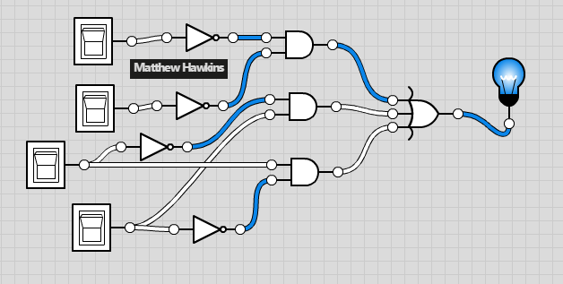

|  |  |  |  |  |
| --- | --- | --- | --- | --- |
| **A** | **B** | **C** | **D** | **F** |
| 0 | 0 | 0 | 0 | 1 |
| 0 | 0 | 0 | 1 | 1 |
| 0 | 0 | 1 | 0 | 1 |
| 0 | 0 | 1 | 1 | 1 |
| 0 | 1 | 0 | 0 | 0 |
| 0 | 1 | 0 | 1 | 1 |
| 0 | 1 | 1 | 0 | 1 |
| 0 | 1 | 1 | 1 | 0 |
| 1 | 0 | 0 | 0 | 0 |
| 1 | 0 | 0 | 1 | 1 |
| 1 | 0 | 1 | 0 | 1 |
| 1 | 0 | 1 | 1 | 0 |
| 1 | 1 | 0 | 0 | 0 |
| 1 | 1 | 0 | 1 | 1 |
| 1 | 1 | 1 | 0 | 1 |
| 1 | 1 | 1 | 1 | 0 |

* Create another truth table here. Are the Truth tables identical?

Yes, the outputs are the same as before.

# Topic: Karnaugh Maps 4-input with worked ex and X states (term 2)

|  |  |  |  |  |
| --- | --- | --- | --- | --- |
| **A** | **B** | **C** | **D** | **F** |
| 0 | 0 | 0 | 0 | X |
| 0 | 0 | 0 | 1 | 1 |
| 0 | 0 | 1 | 0 | X |
| 0 | 0 | 1 | 1 | 1 |
| 0 | 1 | 0 | 0 | 0 |
| 0 | 1 | 0 | 1 | 1 |
| 0 | 1 | 1 | 0 | 1 |
| 0 | 1 | 1 | 1 | X |
| 1 | 0 | 0 | 0 | 0 |
| 1 | 0 | 0 | 1 | 1 |
| 1 | 0 | 1 | 0 | 1 |
| 1 | 0 | 1 | 1 | X |
| 1 | 1 | 0 | 0 | X |
| 1 | 1 | 0 | 1 | 1 |
| 1 | 1 | 1 | 0 | X |
| 1 | 1 | 1 | 1 | X |

* Now take your original truth table from the last ex and make **any 5** of the outputs **X (“Don't care”)**. Draw it here: 🡪

Karnaugh Maps 4-input with worked ex (term 2) **continued**

* Redo the K-map + find the new minimised function, carefully showing your groupings and minterms. Do this here:

|  |  |  |  |  |
| --- | --- | --- | --- | --- |
| AB/CD | 00 | 01 | 11 | 10 |
| 00 | X | 1 | 1 | X |
| 01 | 0 | 1 | X | 1 |
| 11 | X | 1 | X | X |
| 10 | 0 | 1 | X | 1 |

Left group = A’B’C’D A’B’CD A’BC’D A’BCD ABC’D ABCD AB’C’D AB’CD = D

Right group = A’B’CD A’B’CD’ A’BCD A’BCD’ ABCD ABCD’ AB’CD AB’CD’ = C

F = D + C

* Build it in your simulator and screenshot it here (after putting your name somewhere on the circuit):

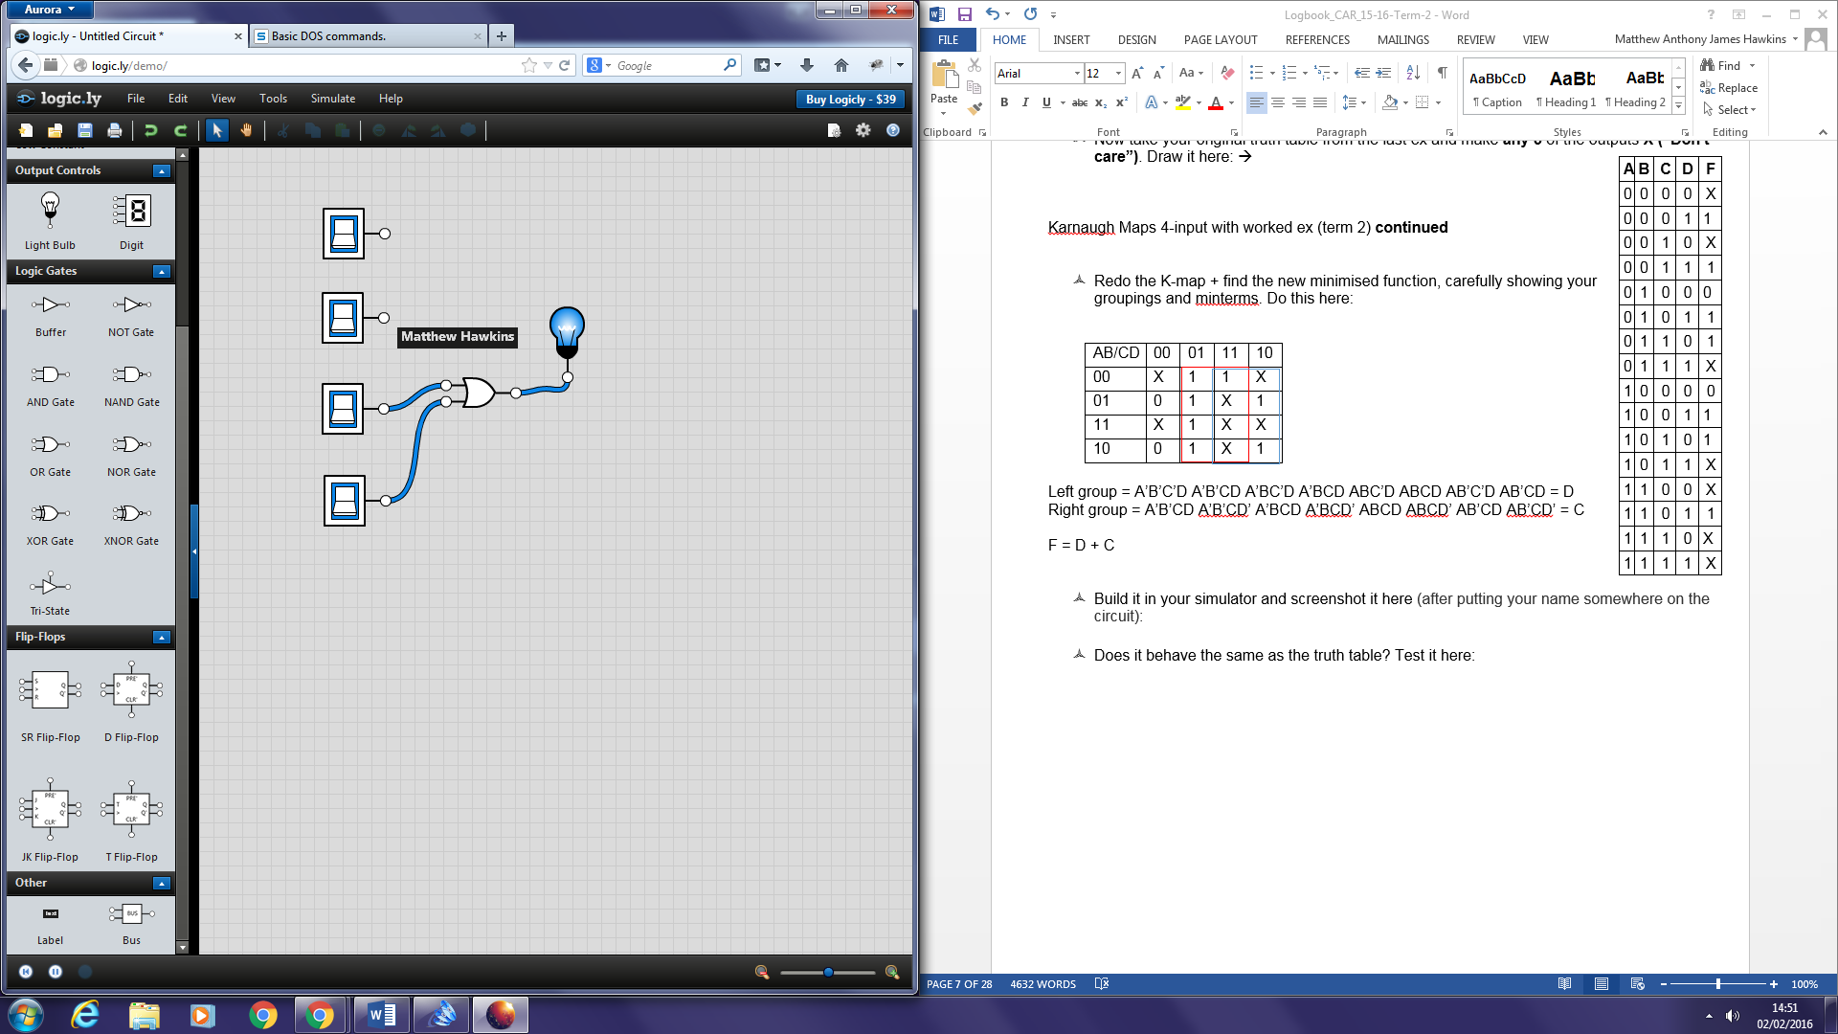

* Does it behave the same as the truth table? Test it here:

The new gate is an OR gate and looking at the previous truth table it follows the same rules as an OR gate. I.e. whenever there is an input of 1 the output is a 1 but when the inputs are both 0 then the output is 0.

# Topic: Unix/Linux Cheat Sheet (term 2)

**- Start this in term 1 but it won't be signed off till term 2 -**

***I would recommend covering this exercise very thoroughly, as it will save you hours of work when you start your revision.***

* Make a table in a word processor (or by hand)
* Summarize every Unix/Linux command you come across in the exercises, in Alphabetical Order, giving examples where you think they may be useful.

|  |  |  |
| --- | --- | --- |
| **Command** | **Use** | **Example** |
| !! | Repeats the last command | e.g. repeats pwd to show which directory you’re in |
| !*n* | Repeats the nth command | e.g. in this case the command to open mysql is used by typing !119 |
| * | Wildcard used for any string of characters | e.g. using the star wildcard to display all the files that have the .html extension in the current folder |
| . | Represents the current directory | e.g. ./filename  - to execute a file in the current directory (unfortunately this does not work on the university VM’s – Permission Denied) |
| .. | Parent directory to the current directory | e.g. using cd to move up to the parent directory |
| / | Root directory | e.g. using cd to move to the root directory |
| ? | Wildcard used to represent exactly one character. | e.g. combining the star wildcard with the question mark wildcard to find all files in the current directory that have exactly “2” digits as their file extension. |
| ~ | Home directory | e.g. using cd ~ to move to the home directory (*note cd by itself also does this)* |
| cd | Just cd takes you back to the home directory | e.g. moving from /me directory to the home directory |
| cd *directoryname* | Change directory, essentially moves you to the specified directory | e.g. moves you to the root directory |
| cd .. | This moves up one directory, child 🡪 parent | e.g. using cd to move up to the parent directory |
| chmod *options filename* | Allows changing of read, write and execute permissions. | chmod o+r *filename* will make the file readable for everyone  chmod o-r *filename* will make it unreadable for others |
| cp *filename*1 *filename*2 | Copies a file | e.g. copies the file index.html and renames the copy home.html |
| ctrl C | Interrupts what you are currently doing | e.g. Exits out of mysql  https://i.gyazo.com/2b0f43e9d91d7dcb9fac7733360a6239.png |
| history | Outputs a list of inputs you have typed in and shows a number for each one (for use with other commands such as !*n*) | e.g. shows first to last (*note – includes anything you input, not just correct commands)* |
| ls | Lists files | e.g. lists all the files in /me |
| ls –a | Lists all files including ones whose names begin with a dot that are normally not seen | e.g. lists all the files include hidden ones in /me |
| ls -l | Lists files in long format which gives lots of useful information | e.g. lists all files and gives extra information of them from the /me directory |
| mkdir *directoryname* | Make a new directory | e.g. making a new directory “testdirectory” in the /me directory |
| mv *filename*1 *filename*2 | Moves a file (gives it a different name or moves it to a different directory) | e.g. moving “test” into “testdirectory” and changing the name to “completedtest” |
| pwd | Tells you where your current location is | e.g. showing that the current folder is “me” |
| rm *filename* | Removes a file | e.g. removes the file “home.html” |
| rm –i | Removes a file but asks for confirmation before actually deleting | e.g. checking before removing the file “index.html” |
| rm –r *directoryname* | Removes a directory and all its files. | e.g. deletes the “testdirectory” from “me” |

# Topic: DOS Simple Guide and Cheat Sheet (term 2)

***I would recommend covering this exercise very thoroughly, as it will save you hours of work when you start your revision.***

* Make a table in a word processor (or by hand)
* Summarize every DOS command you come across in the exercises, in Alphabetical Order, giving examples where you think they may be useful.
* Add an extra column to give the corresponding Unix/Linux command (there won't always be one)

|  |  |  |  |
| --- | --- | --- | --- |
| **Command** | **Use** | **Examples** | **Unix equivalent** |
| ATTRIB | Change file attributes. + adds, - removes. Attributes are A, R, S, H (archive, read only, system and hidden) | ATTRIB –R –A –S –H <PROG.EXE>  attrib +r *file.txt – adds read-only attribute*  attrib +h *file.txt – adds hidden attribute*  attrib -h *file.txt – removes hidden attribute* | chmod |
| C: (A:, D: etc) | Goes to the location of the drive specified | C: | ----- |
| CD | Changes directory | cd\ - goes to highest level (root)  cd.. – goes up one level  cd *pathname* | cd *pathname* |
| DIR | Lists the files in a directory | dir – *lists all files and directories in the current directory*  dir *.exe – *lists all files that end with a .exe extension* | ls |
| EXIT | Exits shell | exit | exit |
| MKDIR  or  MD | Creates a directory | mkdir “*directoryname”*  md *directoryname* | mkdir *directoryname* |
| REN | Renames a directory | ren *file.txt newFile.txt* | mv *file.txt newFile.txt* |
| COPY | Copies a directory | copy *filename.txt c:\windows* – Copies the file “filename.txt” in the current directory to c:\windows | cp *filename*1 *filename*2 |
| DEL | Deletes a file | del *filename.txt* | rm *filename* |
| MOVE | Moves a file | move *filename.txt c:\windows -* Moves the file “filename.txt” in the current directory to c:\windows | mv *filename*1 *filename*2 |
| FC | Compares two files | fc *file1 file2* | diff *file1 file2* |
| MEM | Shows amount of RAM being used | mem | free |
| CLS | Clears screen | cls | clear |
| CHDIR | Changes direction | chdir\ - *goes to root*  chdir.. – *goes up one* | cd |
| ECHO | Echoes outputs to screen | echo *message*  echo %cd% - *equivalent to pwd in linux* | echo *message* |

# Topic: Advanced Unix/Linux 1 - 5 (term 2)

1. Pipes One of the novel contributions of the UNIX system is the idea of a pipe, indicated by a "|" between program names or commands.

A pipe is simply a way to connect the output of one program to the input of another program, so the two run as a sequence of processes -- a pipeline. Try out these:

(screenshot your results after putting your name somewhere on them):

**Answer each of these *in your own words*, put your name (or ID) on the screen and screen shot the results**

1. What does who|wc –l do? Identify yourself uniquely on the screen and screenshot the result.

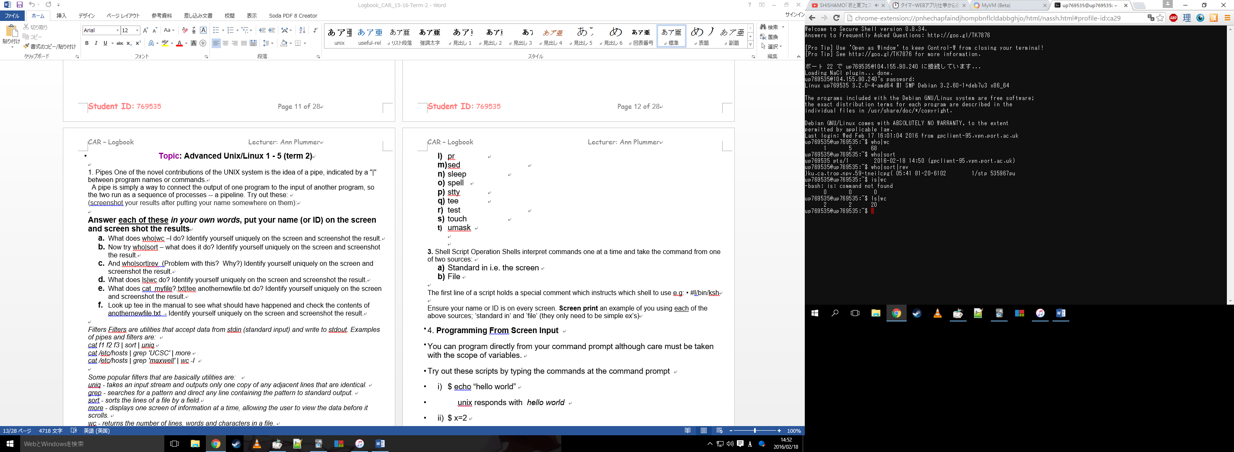

Displays information about the first parameter, in this case 1 represents the number of lines, 5 represents the number of words and 68 the number of characters gathered from the who command output.

1. Now try who|sort – what does it do? Identify yourself uniquely on the screen and screenshot the result.



Who sort displays all the logged in users and then sorts the alphabetically, in the case above it only displays the one user so the sort doesn’t come into affect.

1. And who|sort|rev (Problem with this? Why?) Identify yourself uniquely on the screen and screenshot the result.



Does the same as the previous command (who|sort) but reverses the order of characters compared to the normal output.

1. What does ls|wc do? Identify yourself uniquely on the screen and screenshot the result.



Counts the number of files in the folder by using wc to count how many ls outputs there are.

1. What does cat myfile?.txt|tee anothernewfile.txt do? Identify yourself uniquely on the screen and screenshot the result.

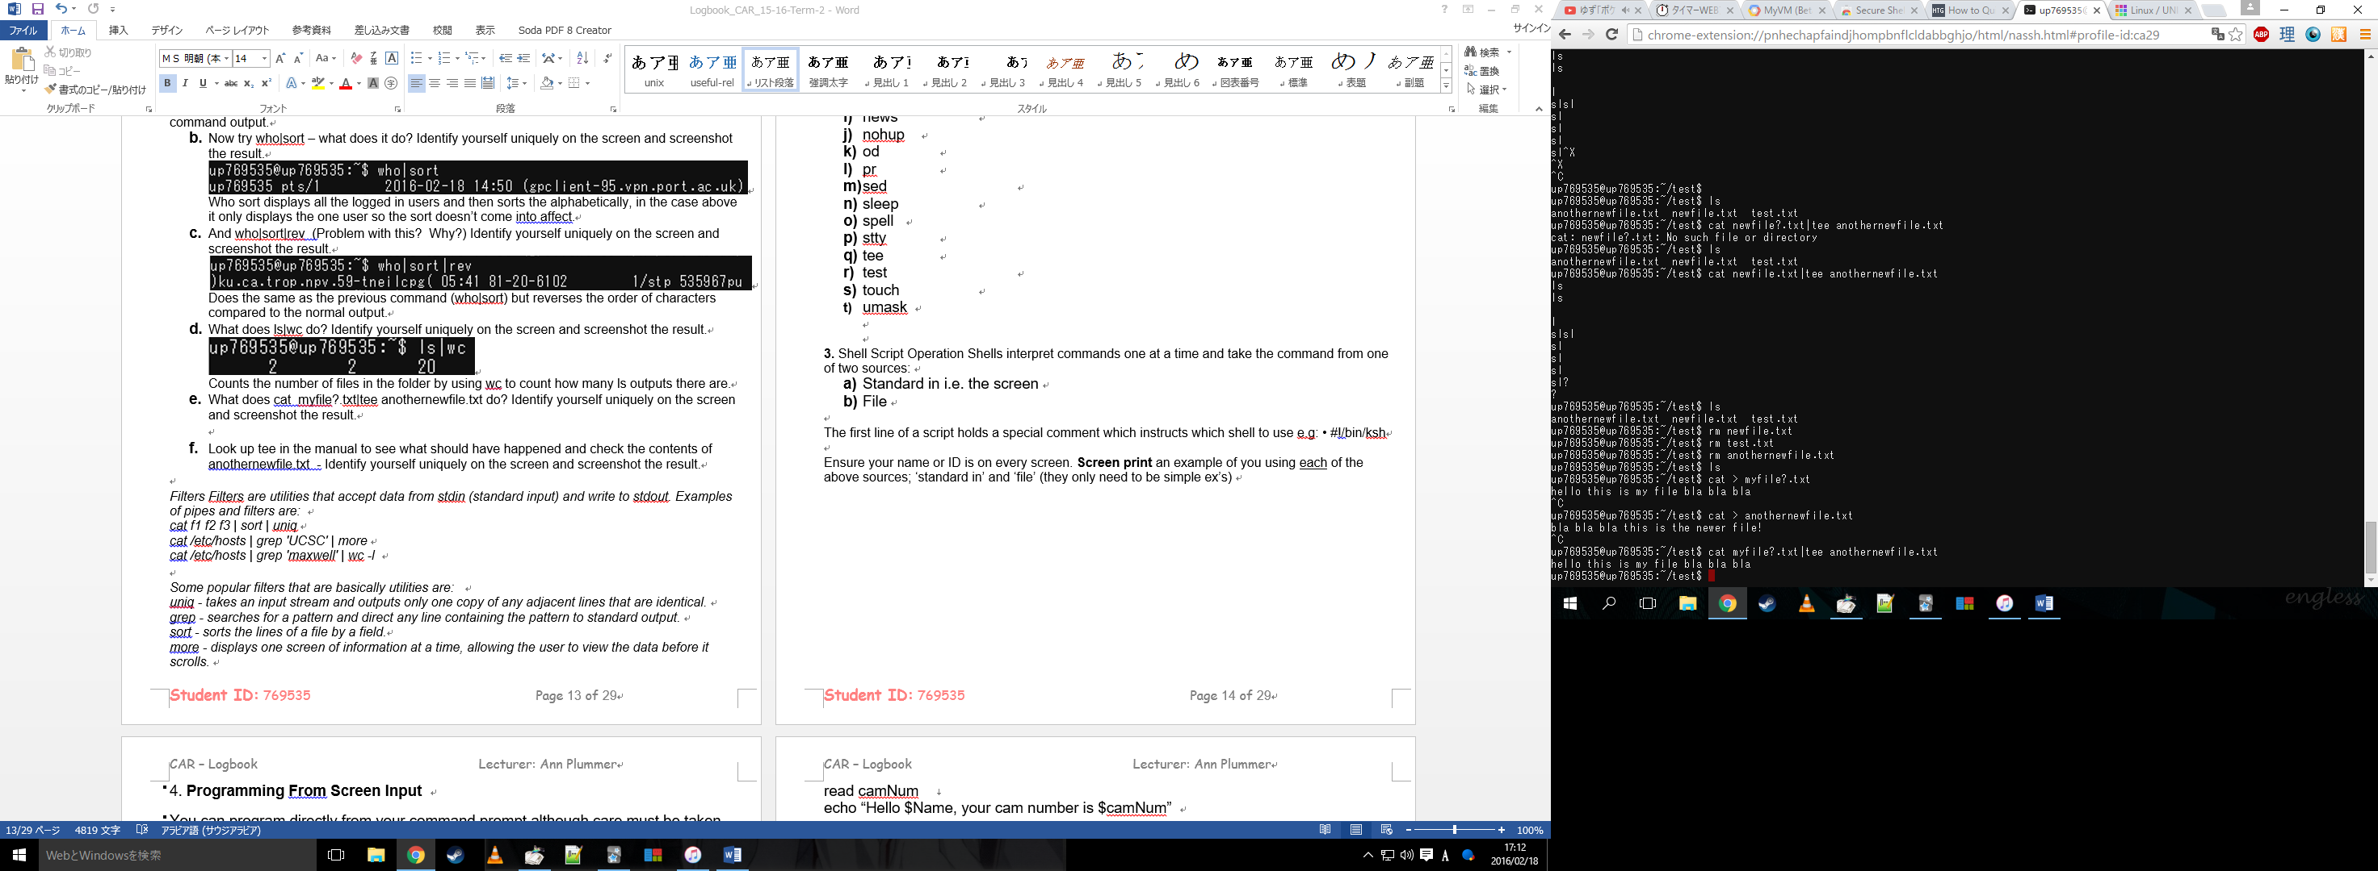

Checking the result in vi we can see that the text is the same.

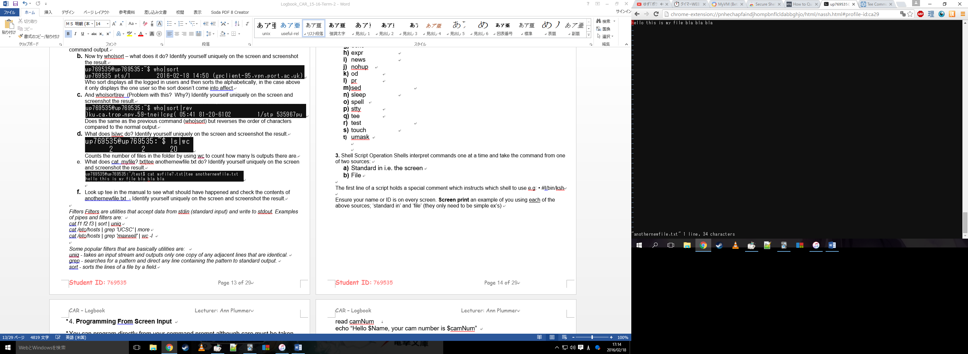

I originally set this text in the file name myfile?.txt. Tee is used to store and few the output of a command, and the cat command copies the content of the first text file to the 2nd. The tee allows you to check the output, I also used vi to double check to be sure of what the command did.

1. Look up tee in the manual to see what should have happened and check the contents of anothernewfile.txt - Identify yourself uniquely on the screen and screenshot the result.

According to the man page the tee command redirects output to any files given as arguments. So this means that the contents of the first command should have been copied to the second which can be showed with a check by opening it with vi.

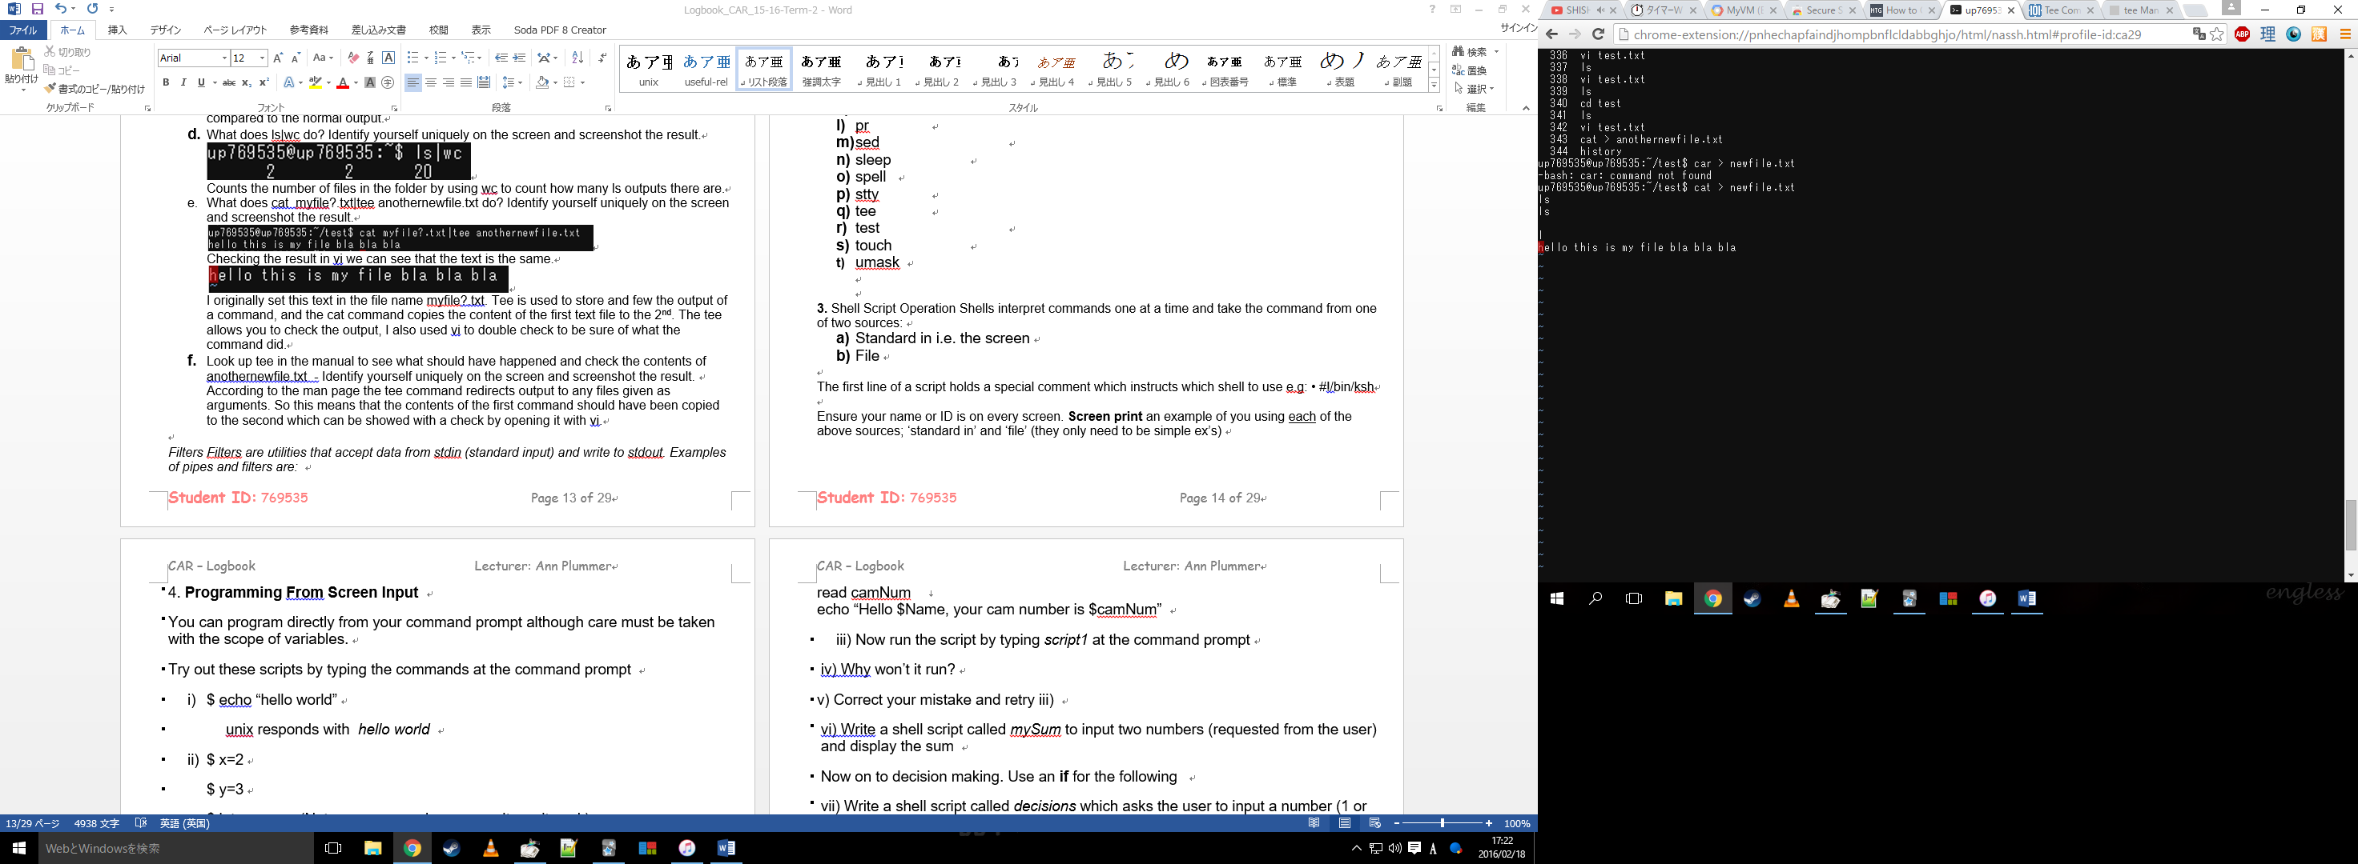

*Note cat > newfile.txt and the following text has nothing to do with this screenshot, it is merely there to incorporate my student ID. The vi file starts where the red cursor is.*

*Filters Filters are utilities that accept data from stdin (standard input) and write to stdout. Examples of pipes and filters are:*

*cat f1 f2 f3 | sort | uniq*

*cat /etc/hosts | grep 'UCSC' | more*

*cat /etc/hosts | grep 'maxwell' | wc -l*

*Some popular filters that are basically utilities are:*

*uniq - takes an input stream and outputs only one copy of any adjacent lines that are identical.*

*grep - searches for a pattern and direct any line containing the pattern to standard output.*

*sort - sorts the lines of a file by a field.*

*more - displays one screen of information at a time, allowing the user to view the data before it scrolls.*

*wc - returns the number of lines, words and characters in a file.*

**2. Explain what each of the following do. Try them out on your version of Unix/Linux. Identify yourself uniquely on the screen and screenshot the result. You can show more than one utility on each screen if you wish. If a utility does not work on your unix, just leave the error message on the screen. Even if a utility doesn’t work, you should still explain what it should do.**

1. awk

awk is programming language used to retrieved and manipulate files. In my version of linux MAWK is the interpreter however there are a variety of different ones depending on the versions.

1. cal

cal outputs a calendar format of the current month along with the current day highlighted.

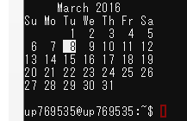

1. calendar

calendar doesn’t work on my version of uni, however, on other systems it displays remainders for different dates, such as Christmas, Easter and any user inputted data such as birthdays, meetings etc.

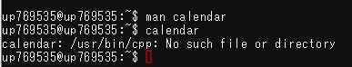

1. comm

Compares two sorted files line by line

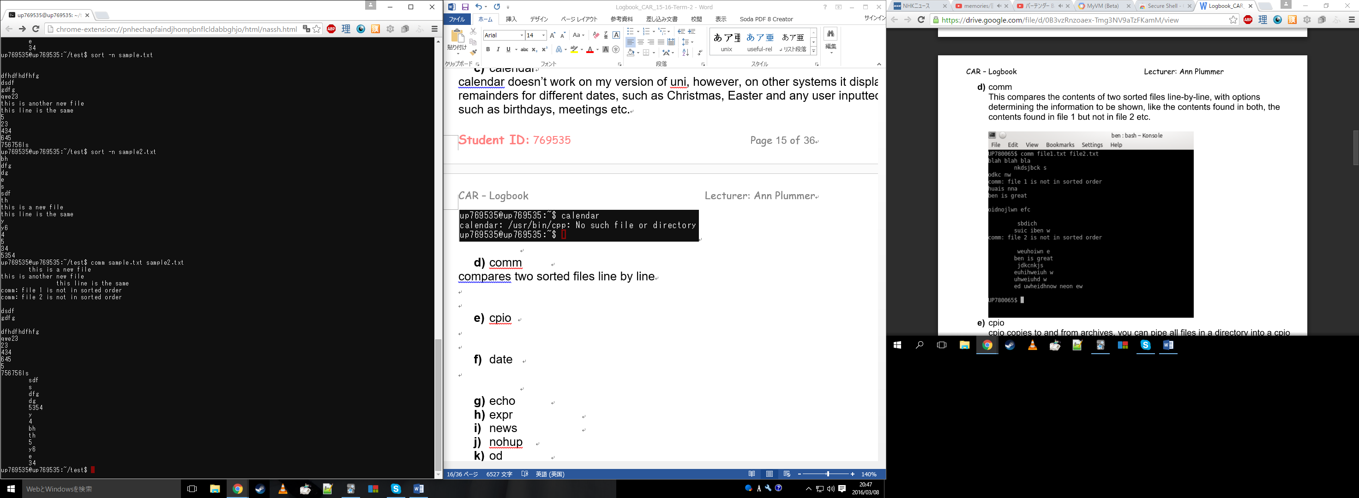

1. cpio

Copies files to and from archives, unfortunately permission is denied on our virtual machines, however, you can use cpio to pipe a set of files into a cpio archive using the following code:

$ ls | cpio –ov > /new.cpio

This will copy all the files in “ls” to the new archive.

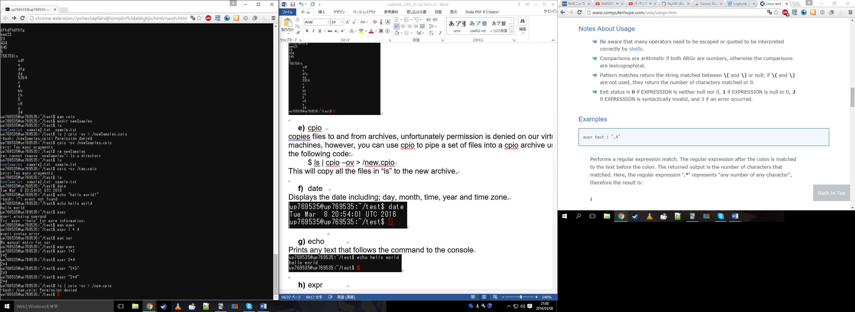

1. date

Displays the date including; day, month, time, year and time zone.

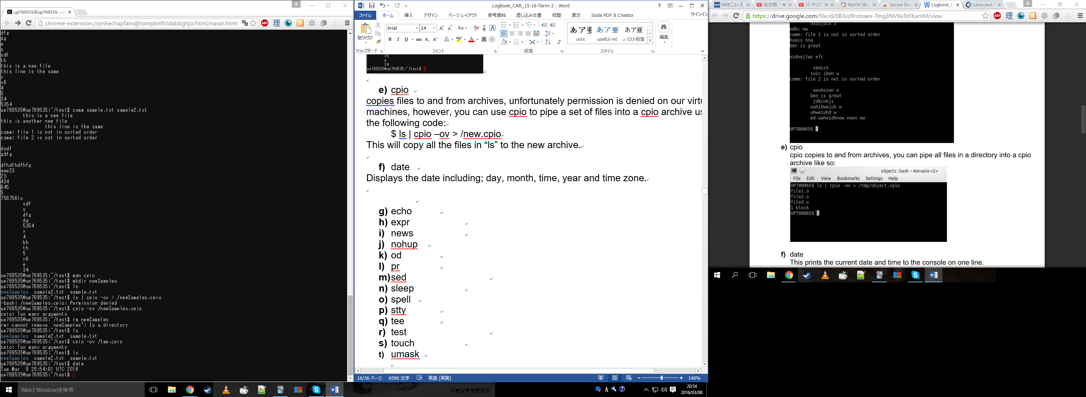

1. echo

Prints any text that follows the command to the console

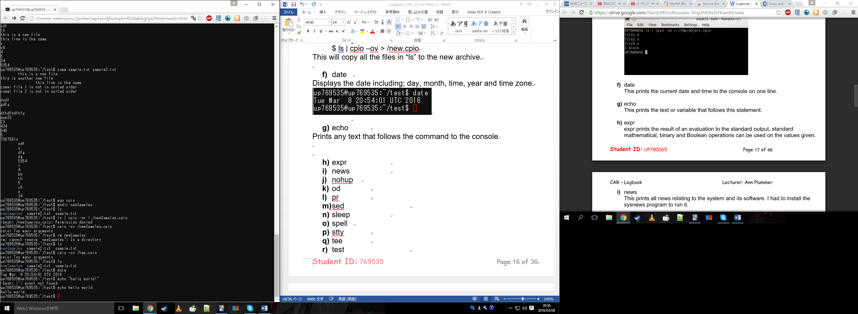

1. expr

Allows you to evaluate expressions in the console for example, addition, subtraction, greater than, less than etc. For some reason this doesn’t work as expected in the version I’m using but the result for the screenshot below should actually be 4.

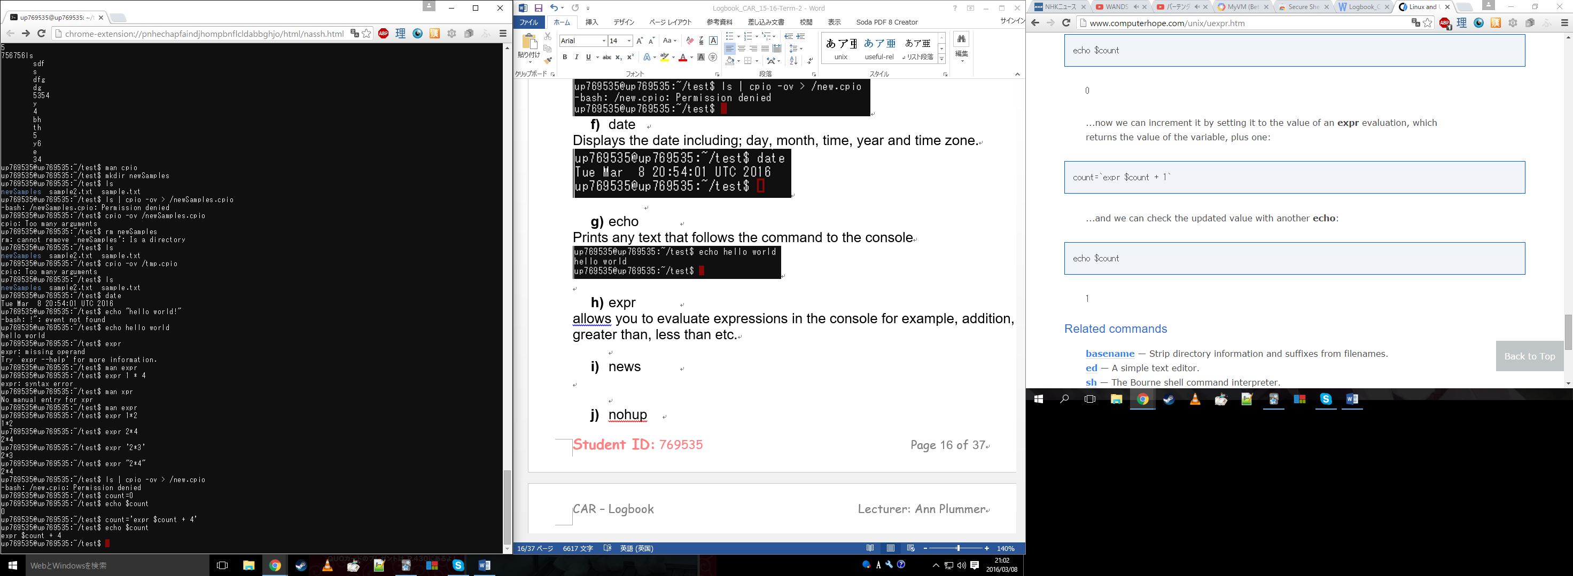*note final output should be* 4 *instead*

1. news

This prints all related information about the system and software to the console. Unfortunately this version does not have it.

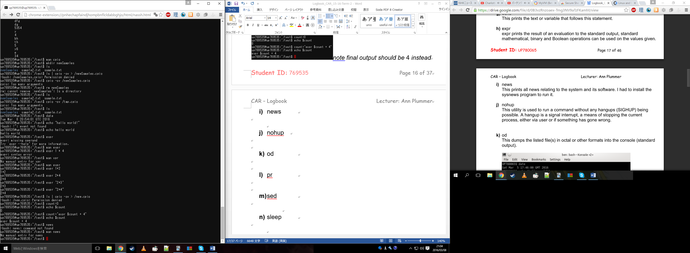

1. nohup

Runs a command without any hangups, where a hangup is a interrupt that would other whys stop or halt the process.

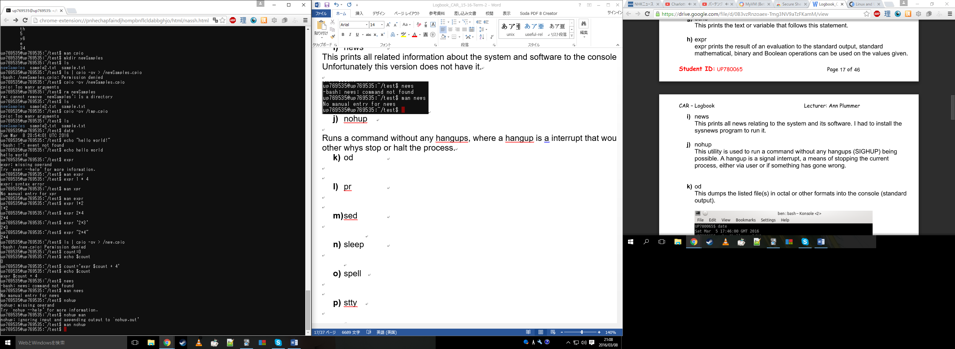

1. od

This displays files in octal format as opposed to normal view.

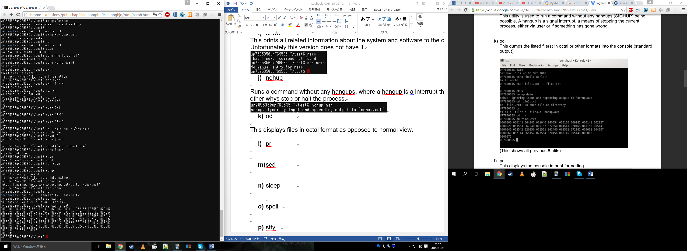

1. pr

Converts text files ready for printing

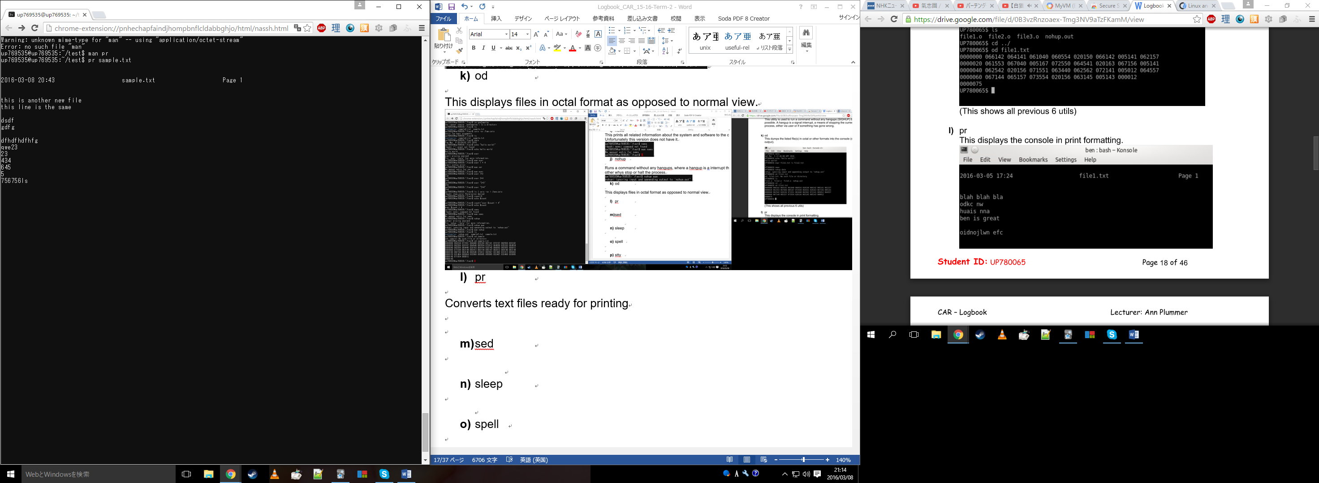

1. sed

Allows transformation on text from a file or input from a pipeline. In the example below, it searches for the word “this” and replaces it with “BOO” with every occurrence of the word in the file.

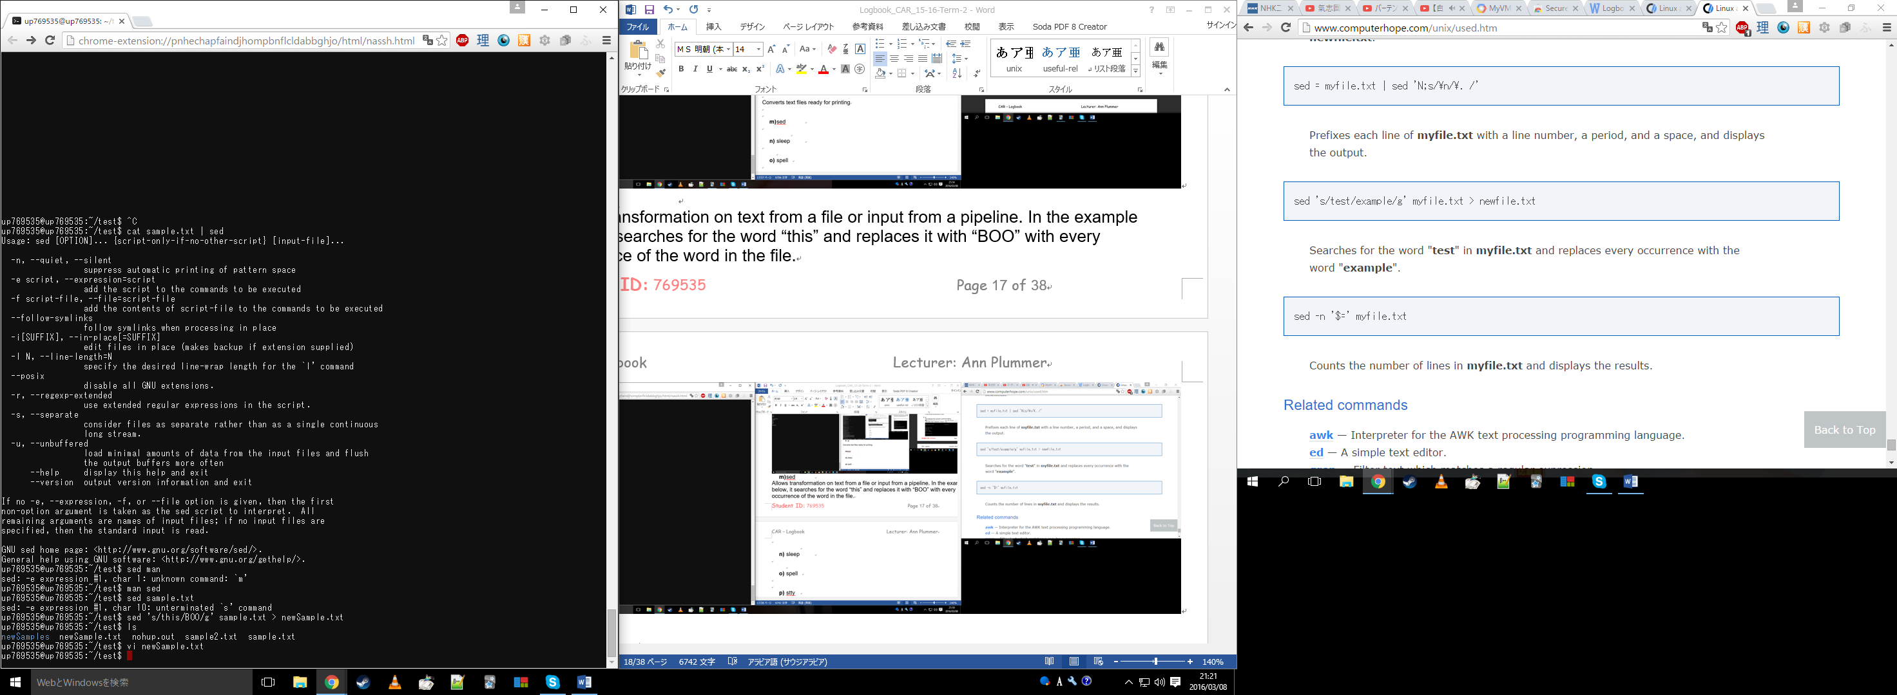

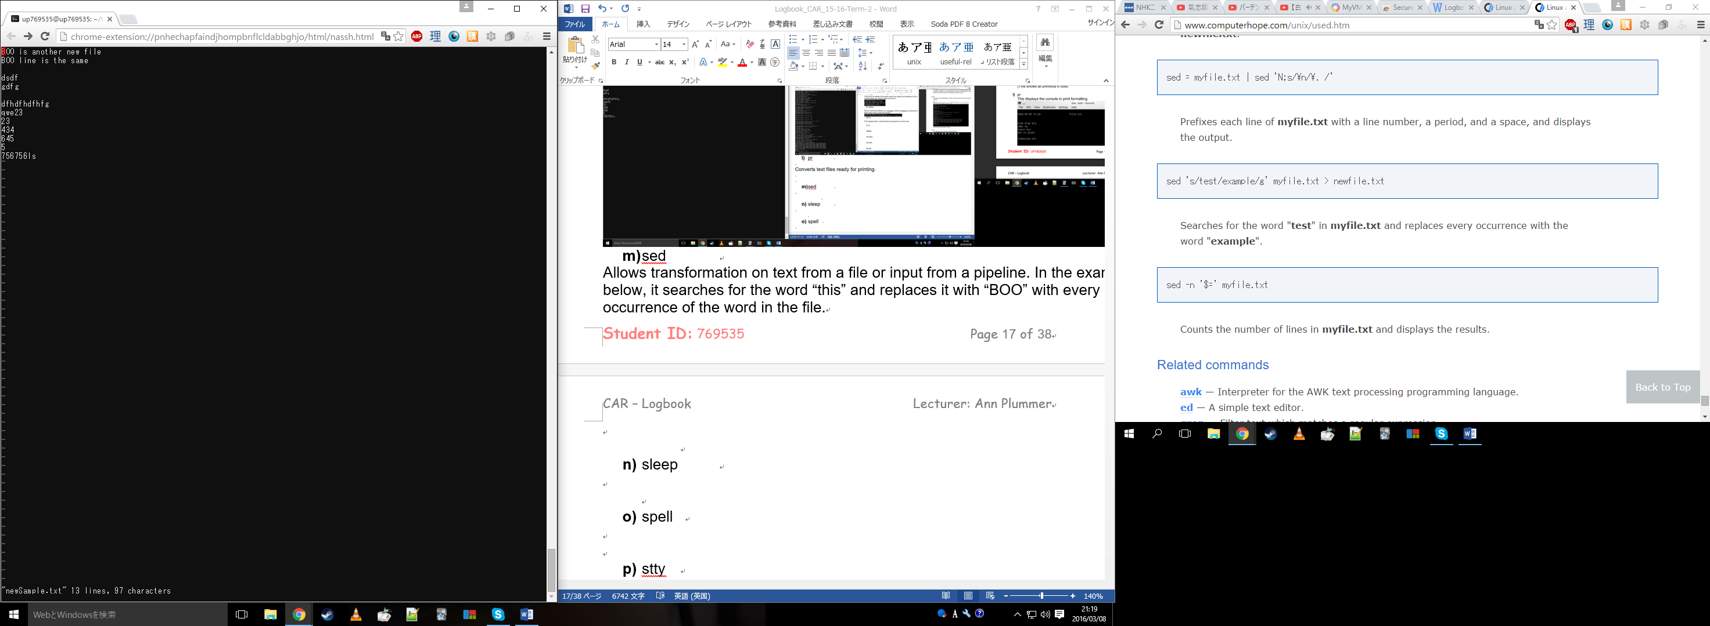

1. sleep

Used to tell the console to sleep for a set amount of time. Uses ‘s’, ‘m’ and ‘h’ for suffixes after an input which allows you to set the seconds, minutes or hours of the sleep time. Not specifying a suffix will use seconds by default.

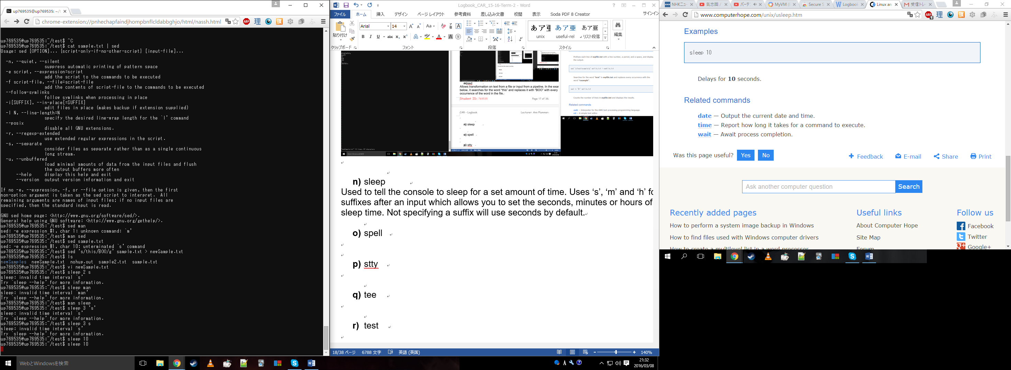

1. spell

This is a spell checker which will print every word that is spelled incorrectly on each line. Unfortunately this does not come with the version I am using.

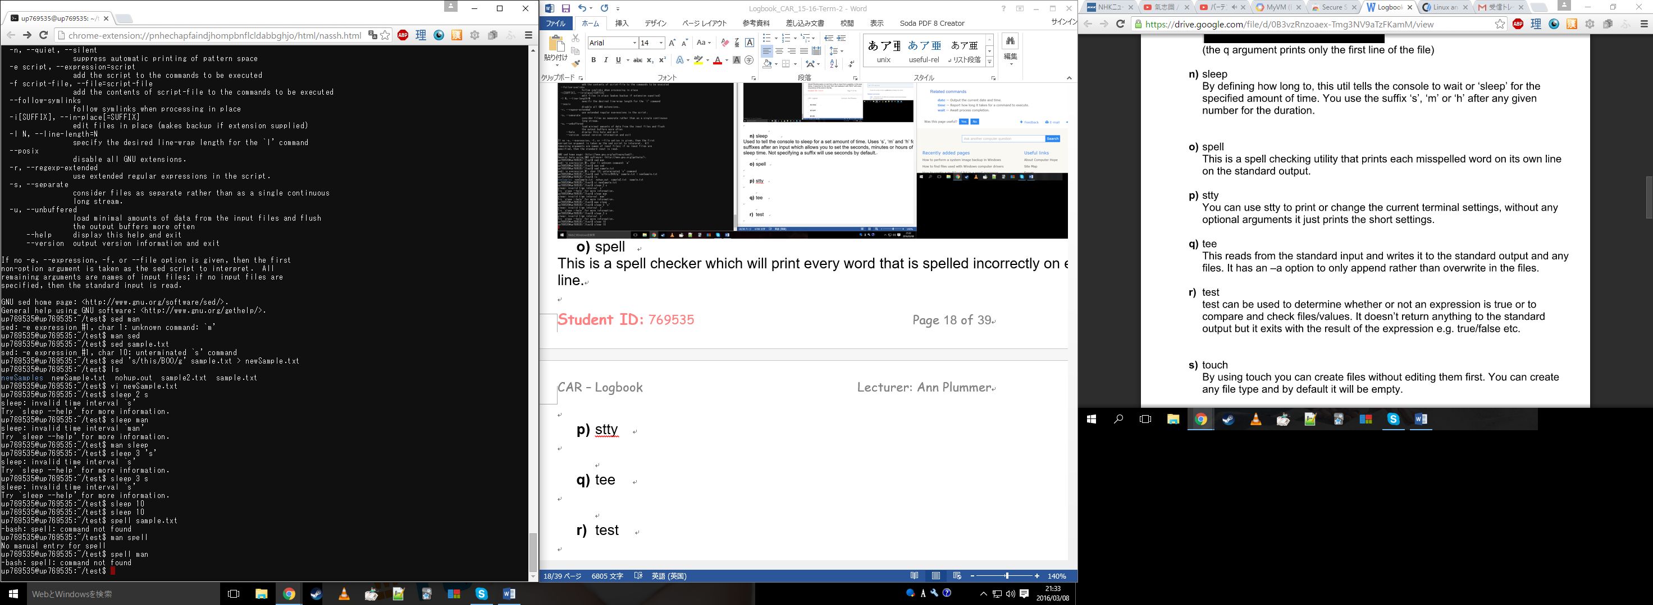

1. stty

Allows the user to print or change terminal characteristics.

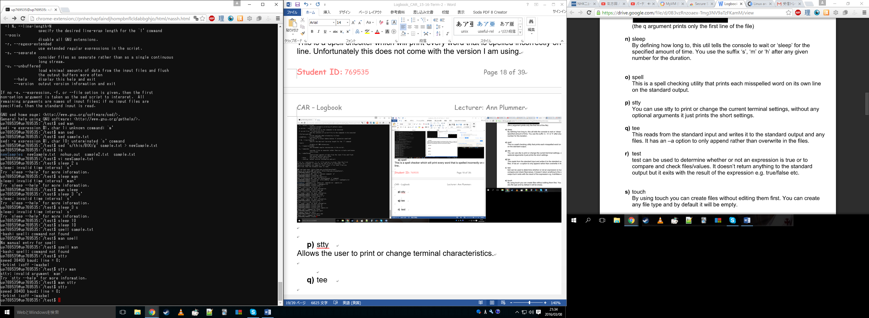

1. tee

Reads and writes to and from standard input and output. In the example below the output of ls is given to wc which counts the lines from ls and then outputs it to text in total.txt.

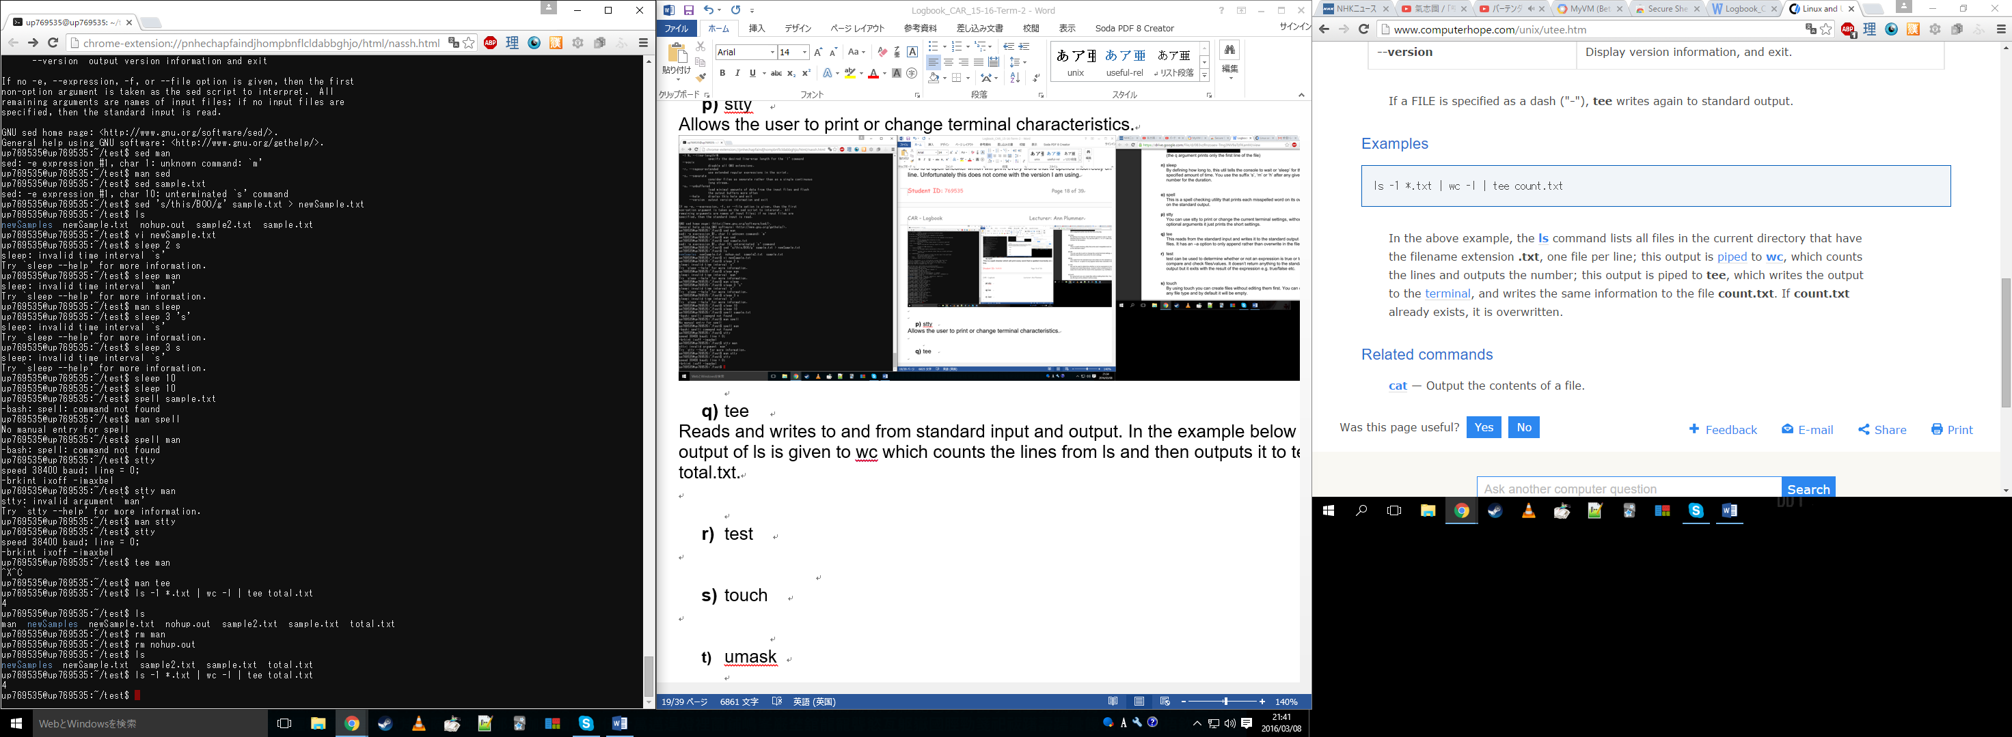

1. test

Allows you to check file types and to compare values, for example the following screenshot tests if sample.txt exists using –e and a basic if statement.

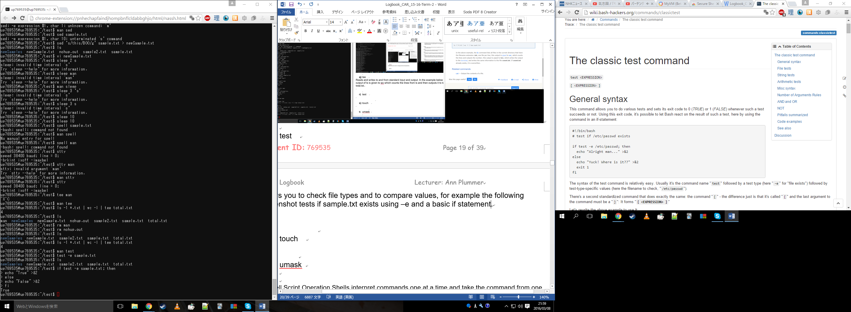

1. touch

Allows you to create files without editing them, files of any type can be made and will be empty by default.

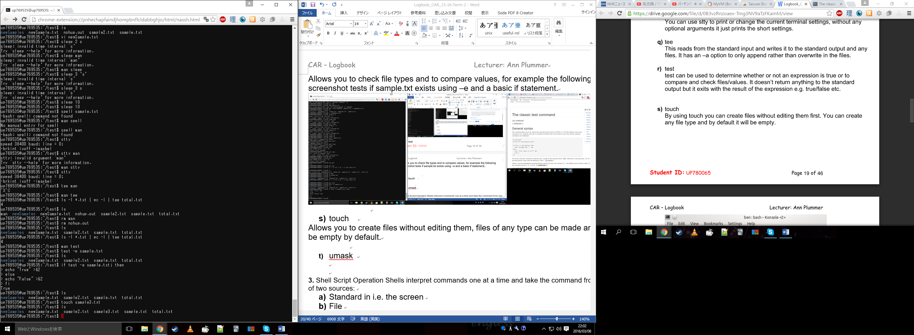

1. umask

Allows you to return or set the value of the system’s shells permissions over creating files and programs. Unfortunately this command is not available in the version I am using.

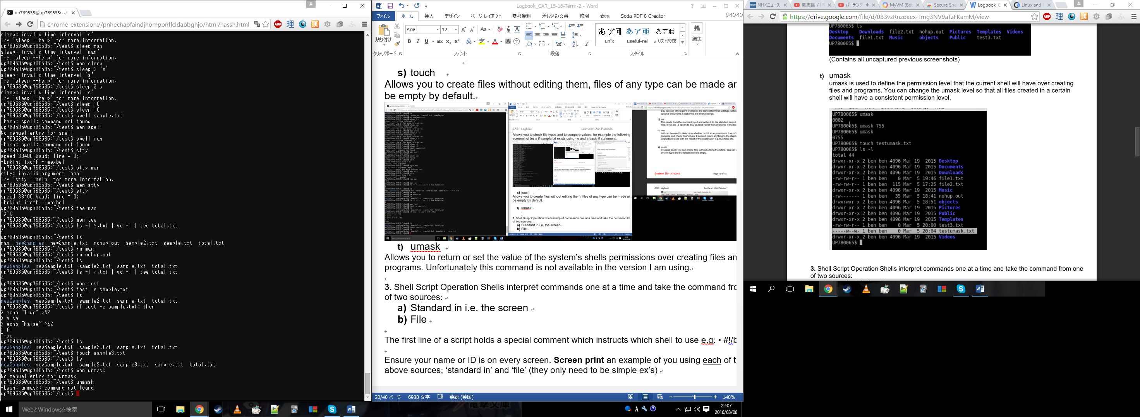

**3.** Shell Script Operation Shells interpret commands one at a time and take the command from one of two sources:

1. Standard in i.e. the screen
2. File

The first line of a script holds a special comment which instructs which shell to use e.g: • #!/bin/ksh

Ensure your name or ID is on every screen. **Screen print** an example of you using each of the above sources; ‘standard in’ and ‘file’ (they only need to be simple ex’s)

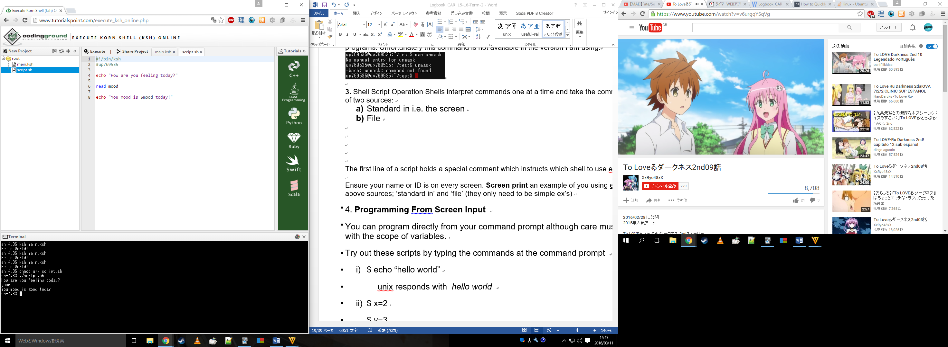

4. **Programming From Screen Input**

You can program directly from your command prompt although care must be taken with the scope of variables.

Try out these scripts by typing the commands at the command prompt

1. $ echo “hello world”

unix responds with hello world

1. $ x=2

$ y=3

$ let z=x+y (Note – no spaces in z=x+y or it won’t work)

$ echo $z

unix responds with 5

**Screenshot your results here (with your name clearly visible):**

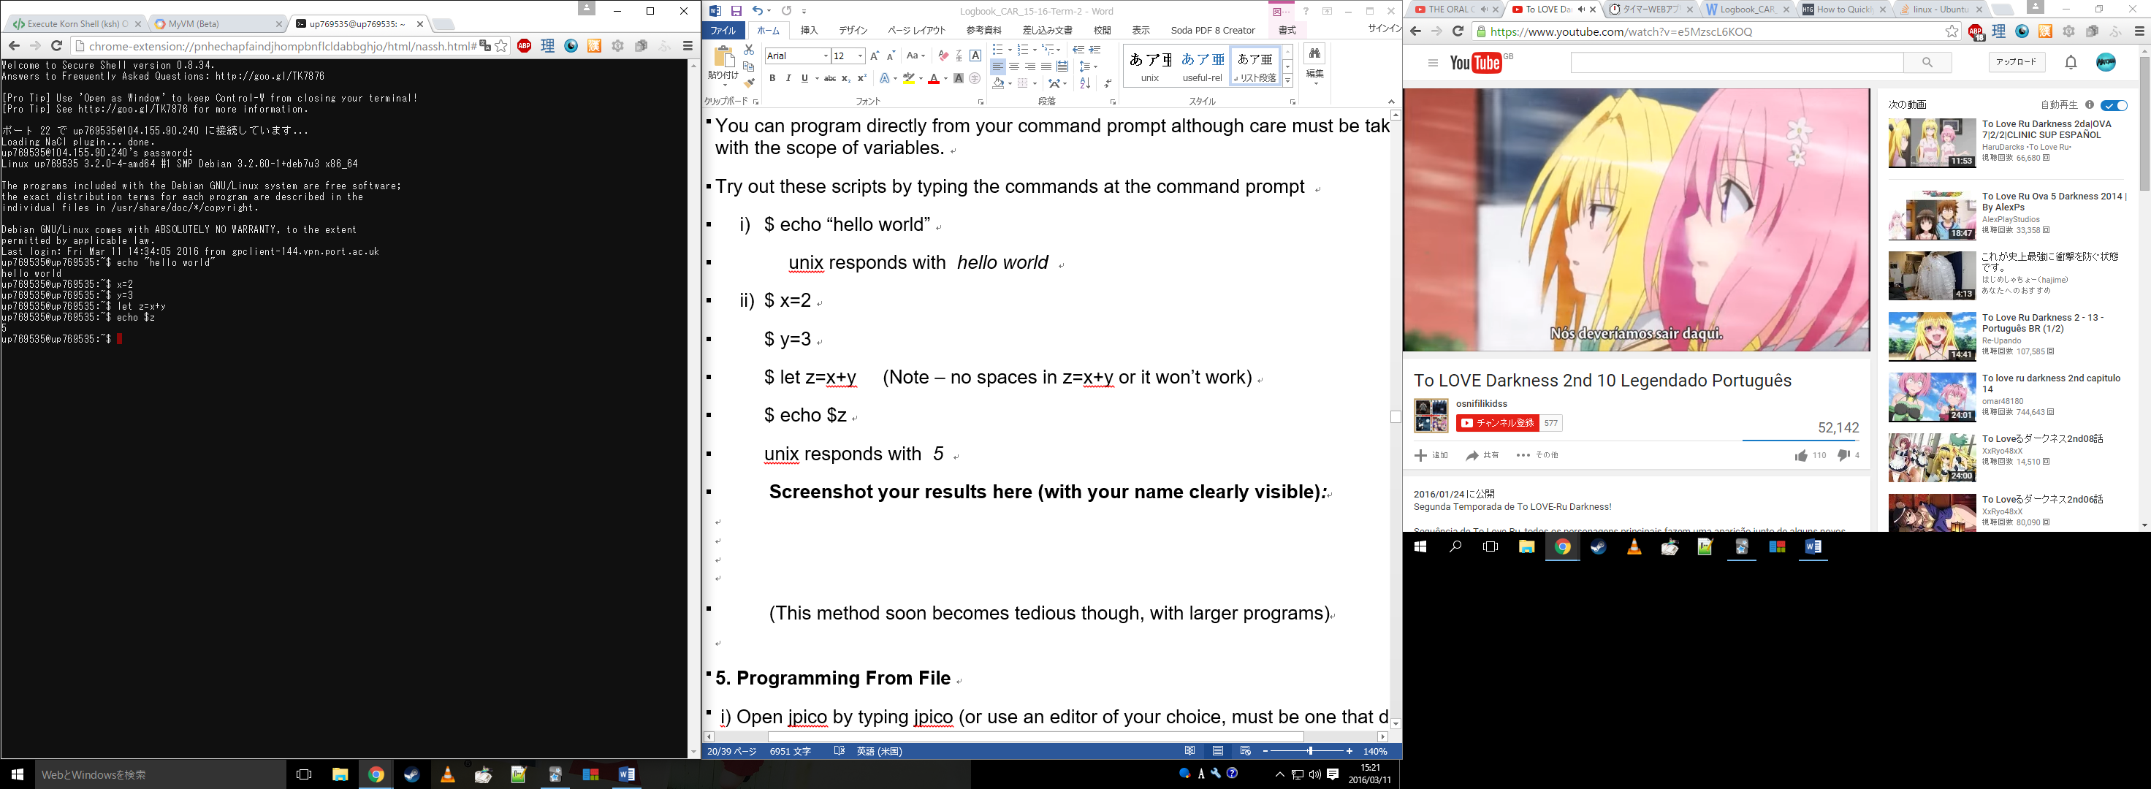

(This method soon becomes tedious though, with larger programs)

**5. Programming From File**

i) Open jpico by typing jpico (or use an editor of your choice, must be one that does not format the text)

ii) Create the following script and name it script1

#!/bin/ksh   
echo “Please enter your name”   
read Name   
echo “Please enter your CAM number”   
read camNum   
echo “Hello $Name, your cam number is $camNum”

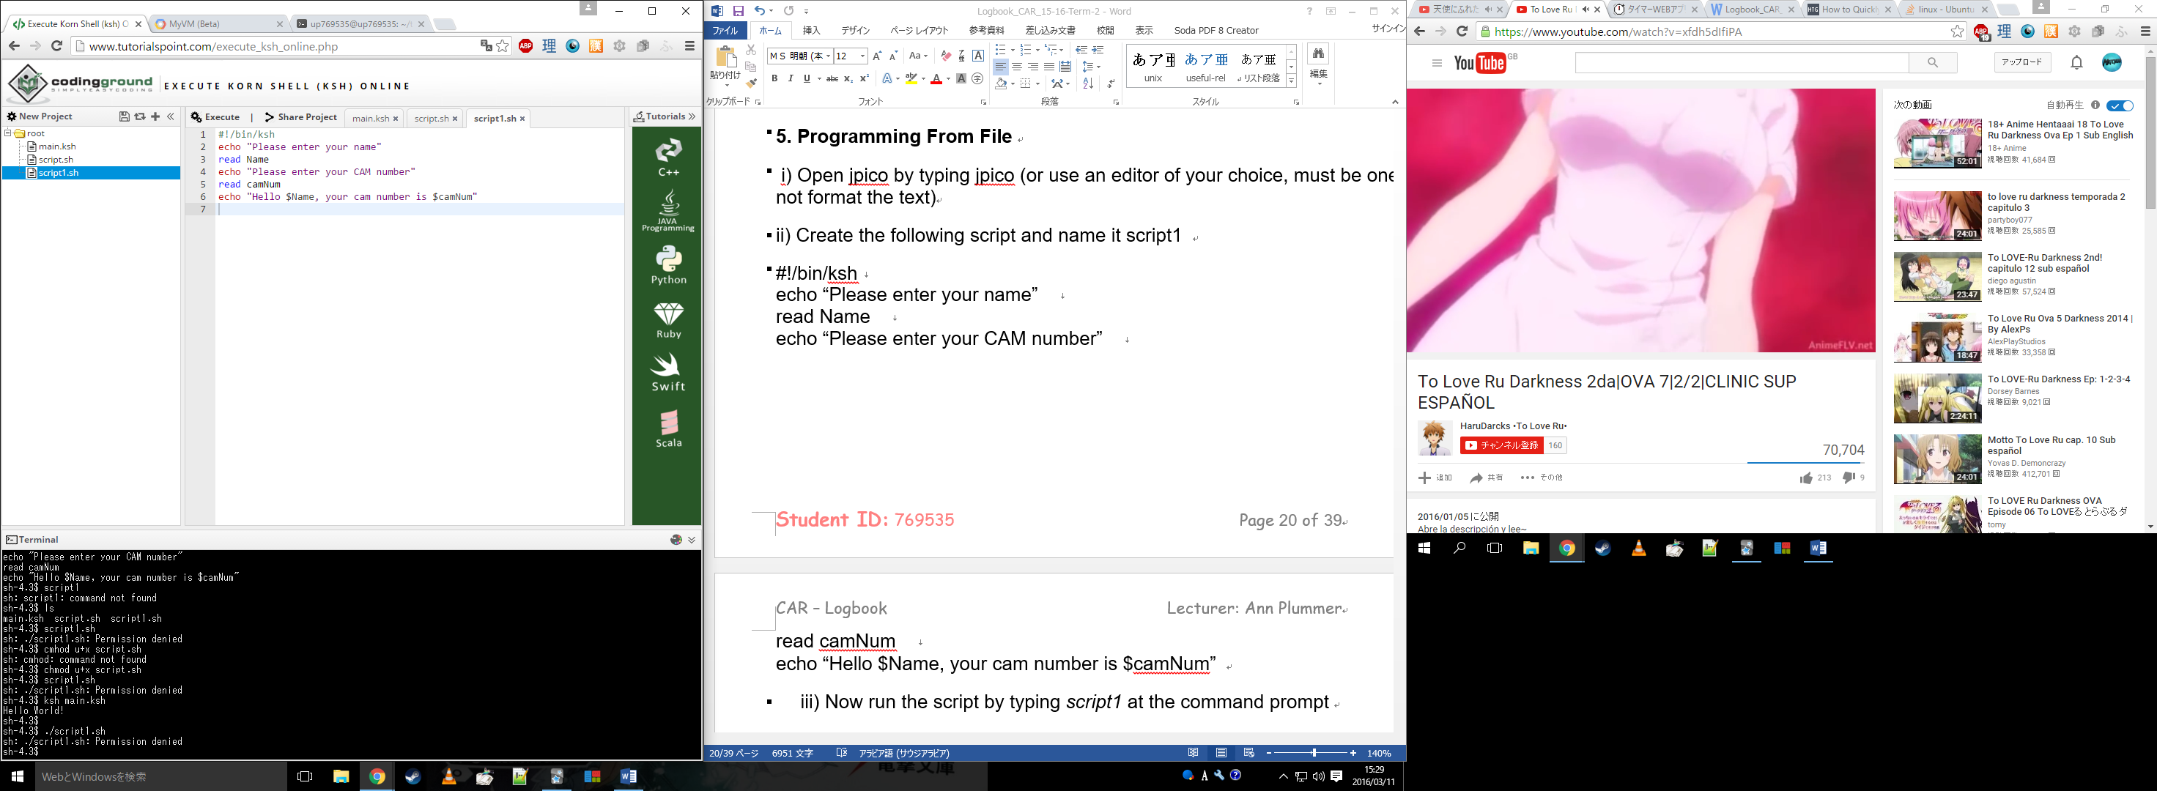

1. Now run the script by typing script1 at the command prompt
2. Why won’t it run?



The file does not have the correct permissions to be able to run it yet.

1. Correct your mistake and retry iii)

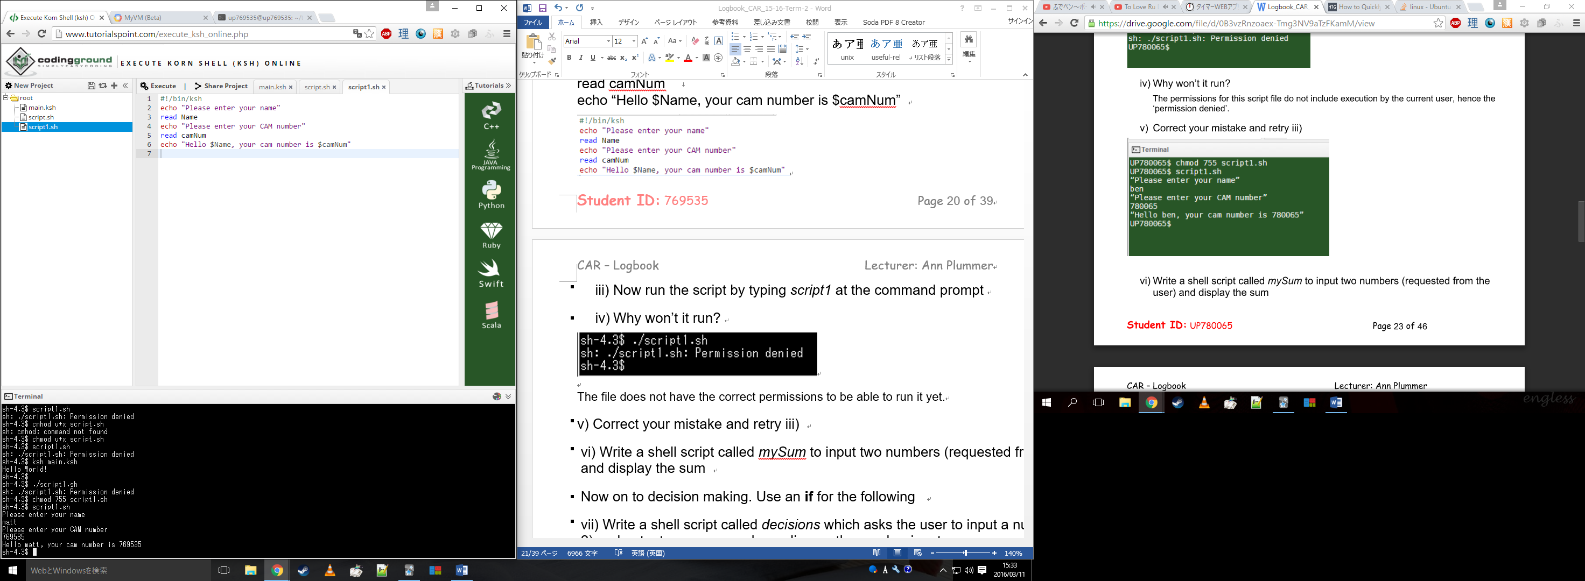

1. Write a shell script called mySum to input two numbers (requested from the user) and display the sum

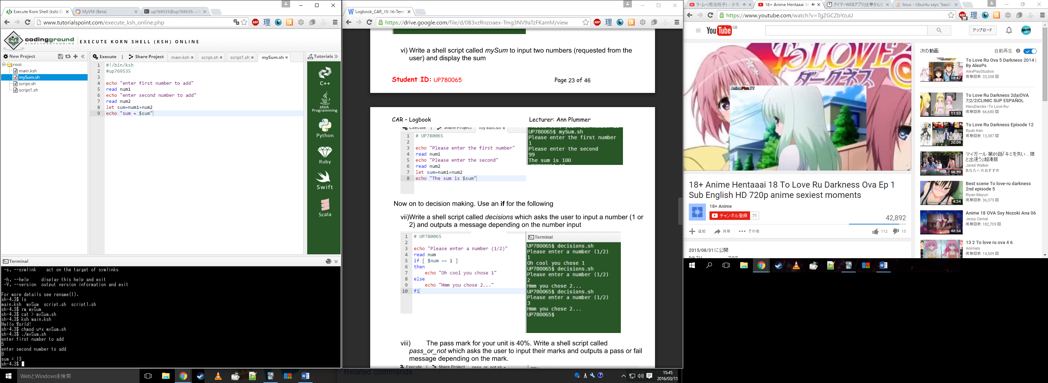

Now on to decision making. Use an **if** for the following

1. Write a shell script called decisions which asks the user to input a number (1 or 2) and outputs a message depending on the number input

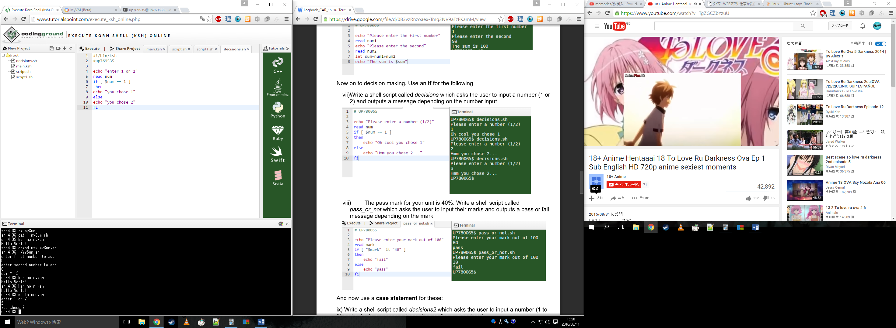

1. The pass mark for your unit is 40%. Write a shell script called pass_or_not which asks the user to input their marks and outputs a pass or fail message depending on the mark.

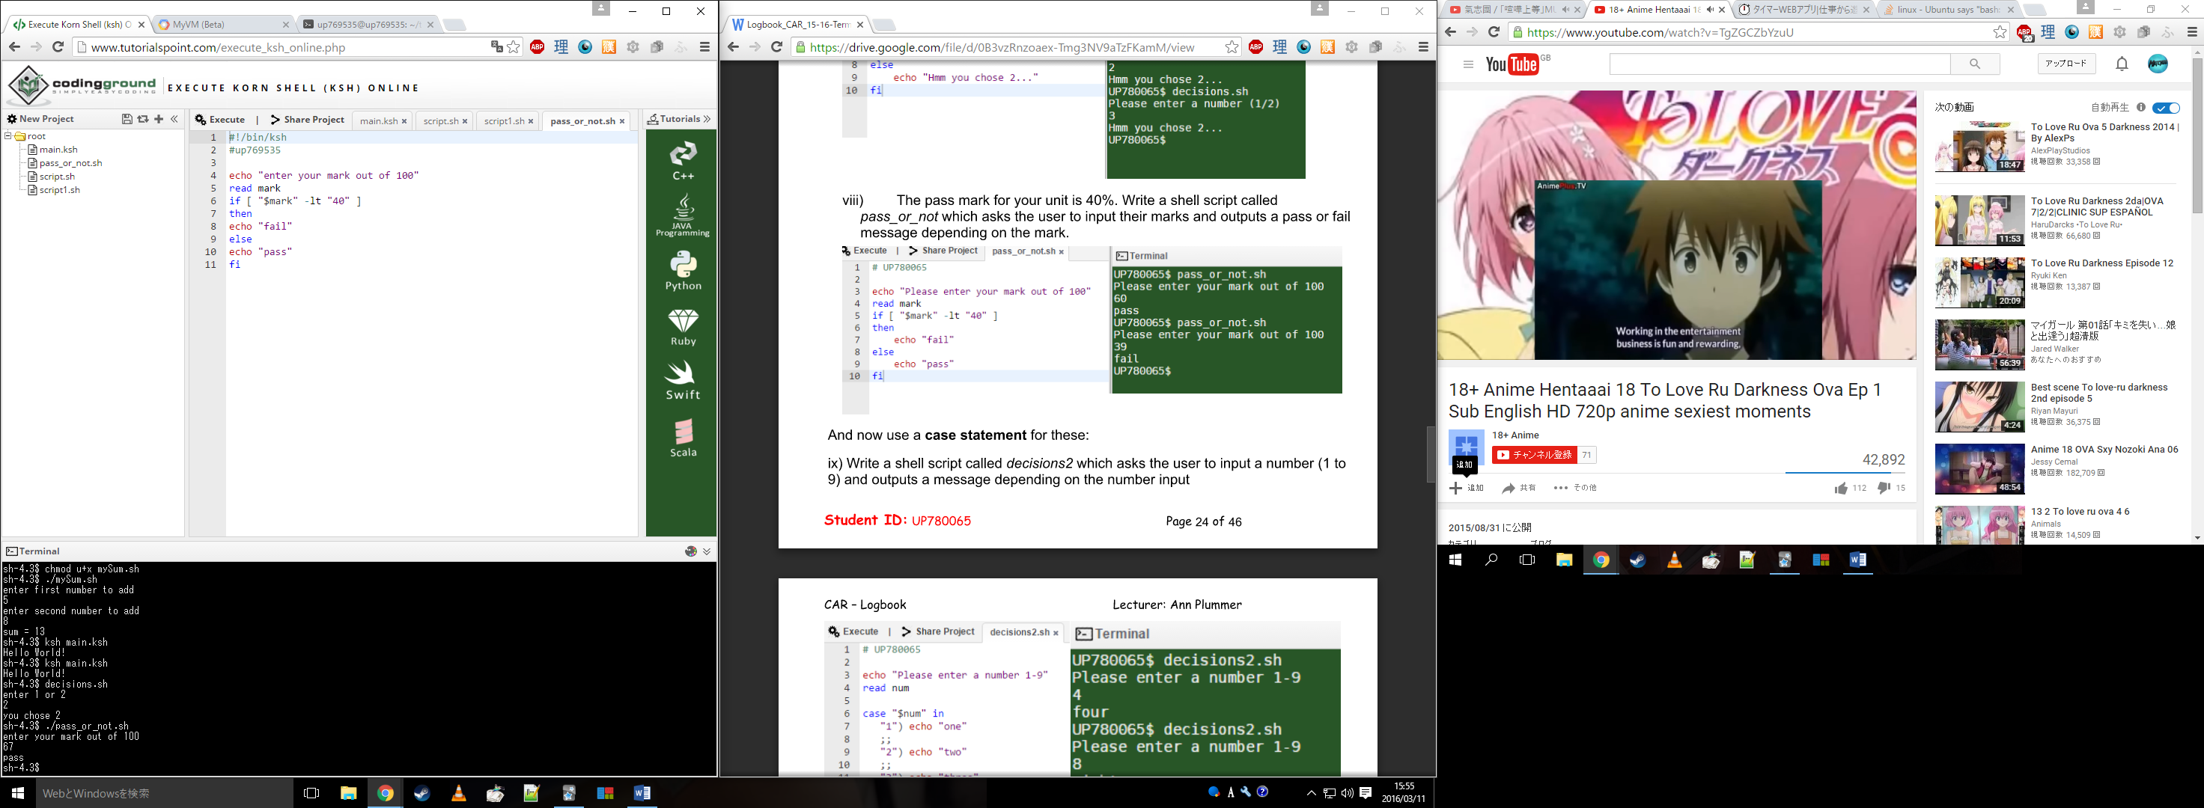

And now use a **case statement** for these:

1. Write a shell script called decisions2 which asks the user to input a number (1 to 9) and outputs a message depending on the number input

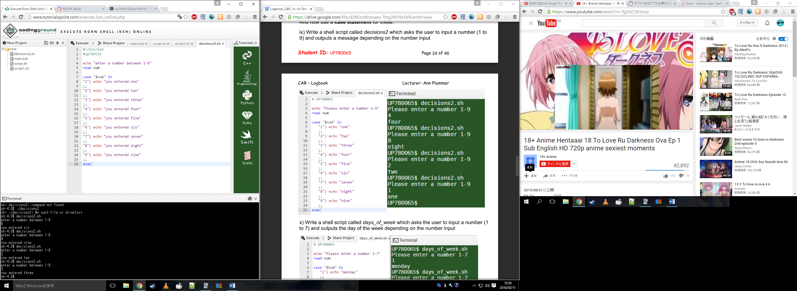

1. Write a shell script called days_of_week which asks the user to input a number (1 to 7) and outputs the day of the week depending on the number input

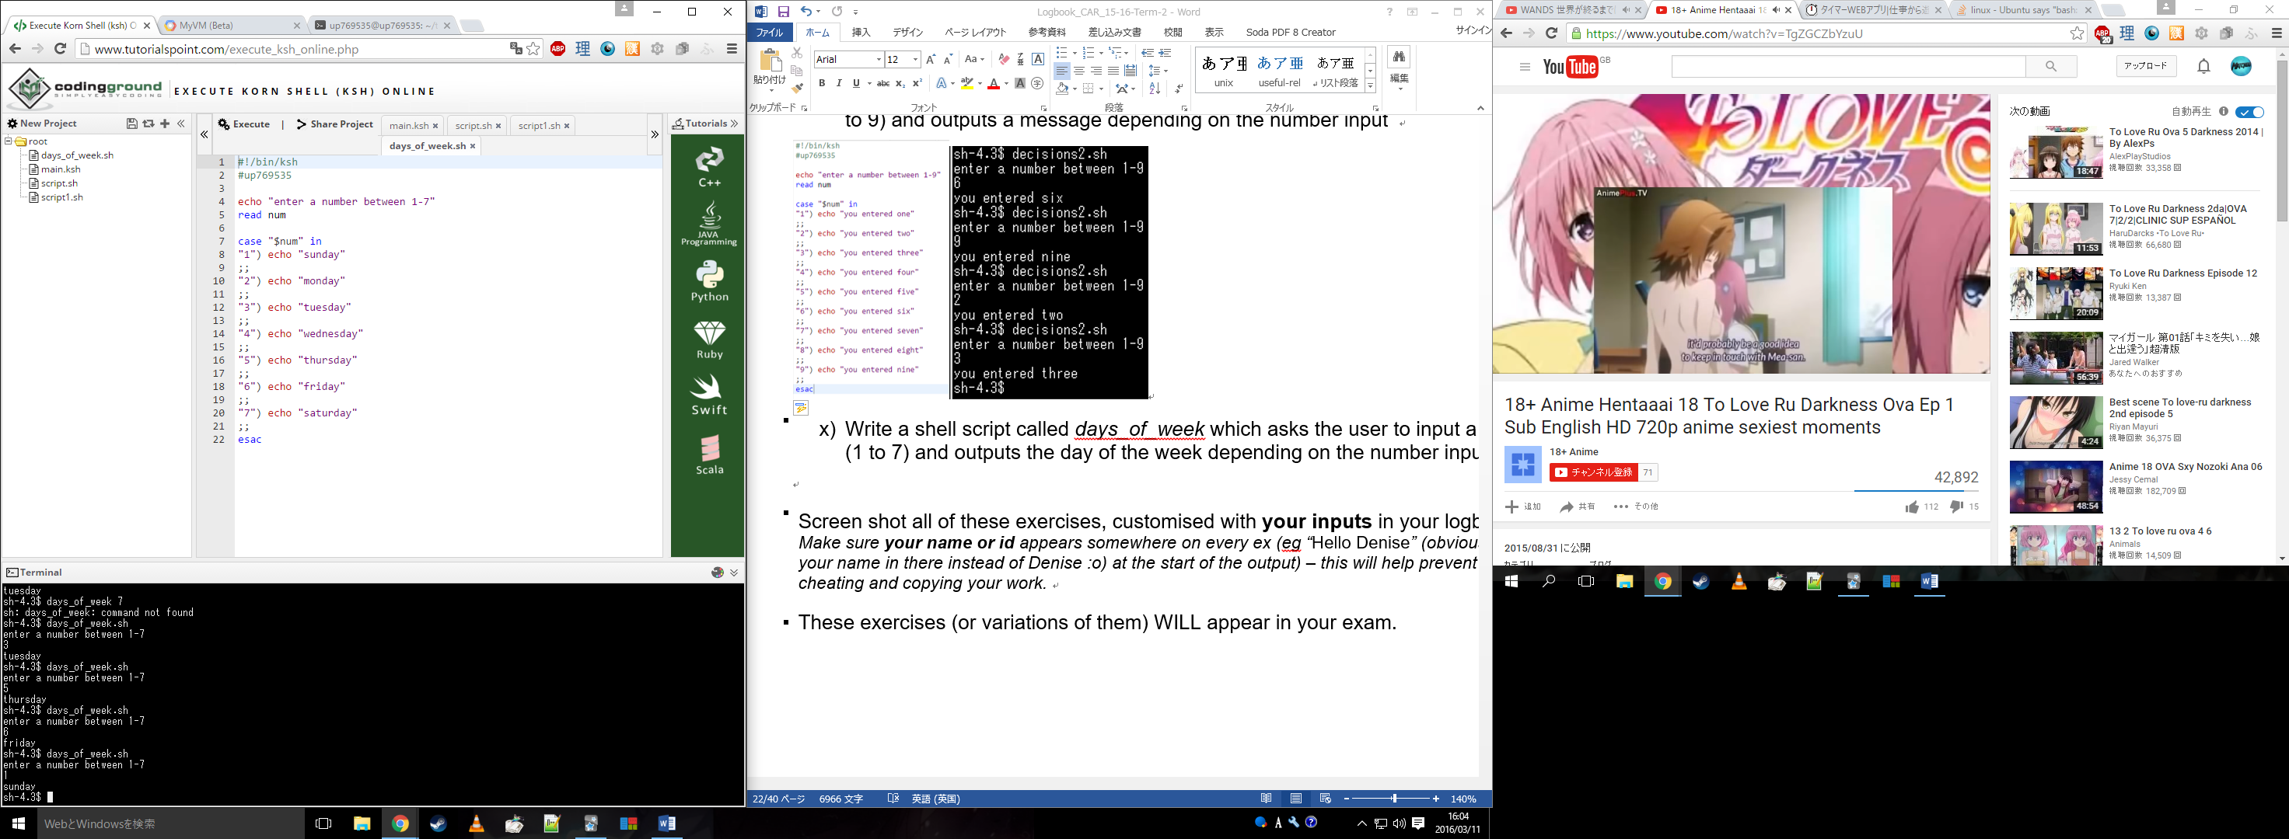

Screen shot all of these exercises, customised with **your inputs** in your logbook. Make sure **your name or id** appears somewhere on every ex(eg “Hello Denise” (obviously putting your name in there instead of Denise :o) at the start of the output) – this will help prevent people cheating and copying your work.

These exercises (or variations of them) WILL appear in your exam.

# Topic: Advanced Unix/Linux extra ex's 1 - 2 (term 2)

1. Write a program that prompts the user for two integers and then prints:

• The two numbers input

• The sum

• The difference

• The product

• The average

And any suitable messages you think might enhance your program**.**

**Make sure** your name or id **is in there somewhere (eg “*Thanks Bob*”) – this will help prevent people cheating and copying your work.**

***Screenshot your results here (with your name or id clearly visible):***

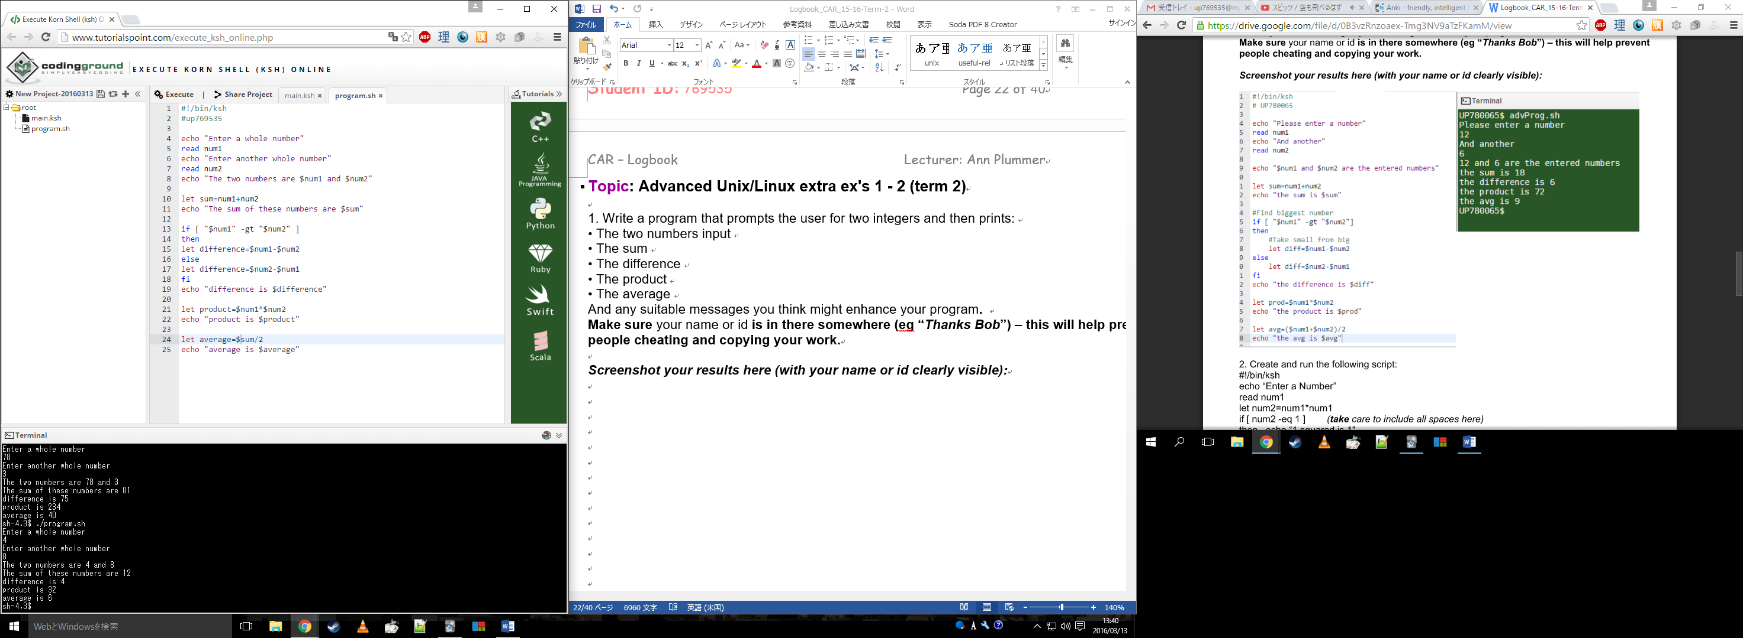

2. Create and run the following script:

#!/bin/ksh

echo “Enter a Number”

read num1

let num2=num1*num1

if [ num2 -eq 1 ] *(****take*** *care to include all spaces here)*

then echo “1 squared is 1"

else echo "$num1 squared is $num2"

fi

***Screenshot your results here (with your name clearly visible):***

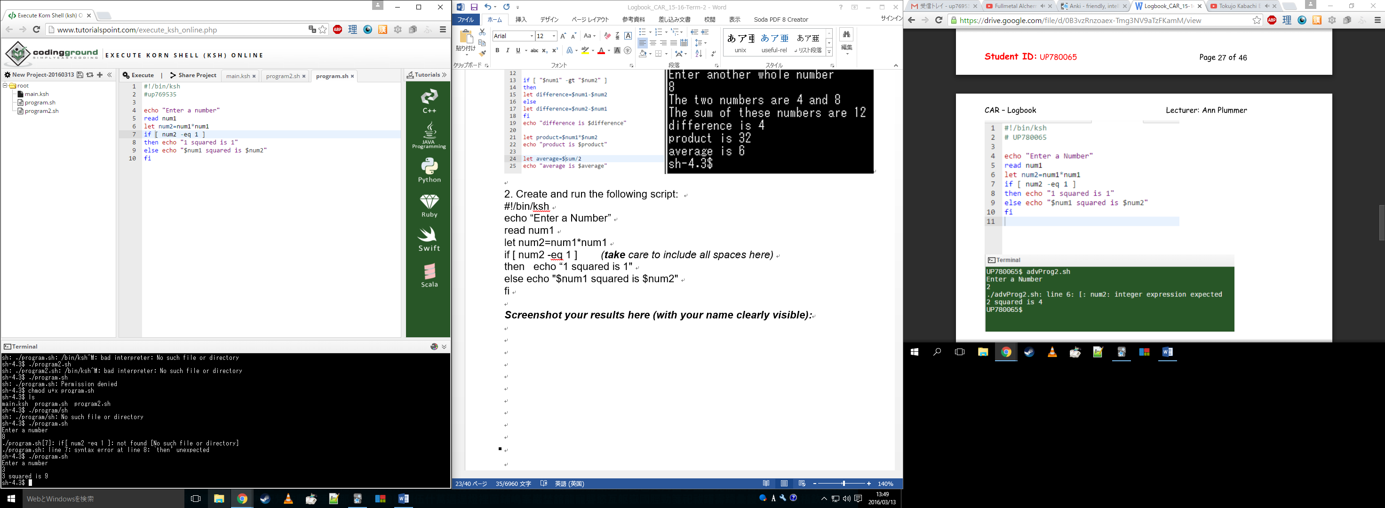

# Topic: Advanced Unix/Linux extra ex's 3 - 4 (term 2)

# 

3. Now try adapting the script **(from the last ex)** so that it asks the user if they want another go, i.e. if they say *yes*, loop around and run again and if they say *no* **then** exit the script. **Make sure** your name **is in there somewhere (eg “*Would you like another go Bob*”) – this will help prevent people cheating and copying your work.**

***Screenshot your results here:***

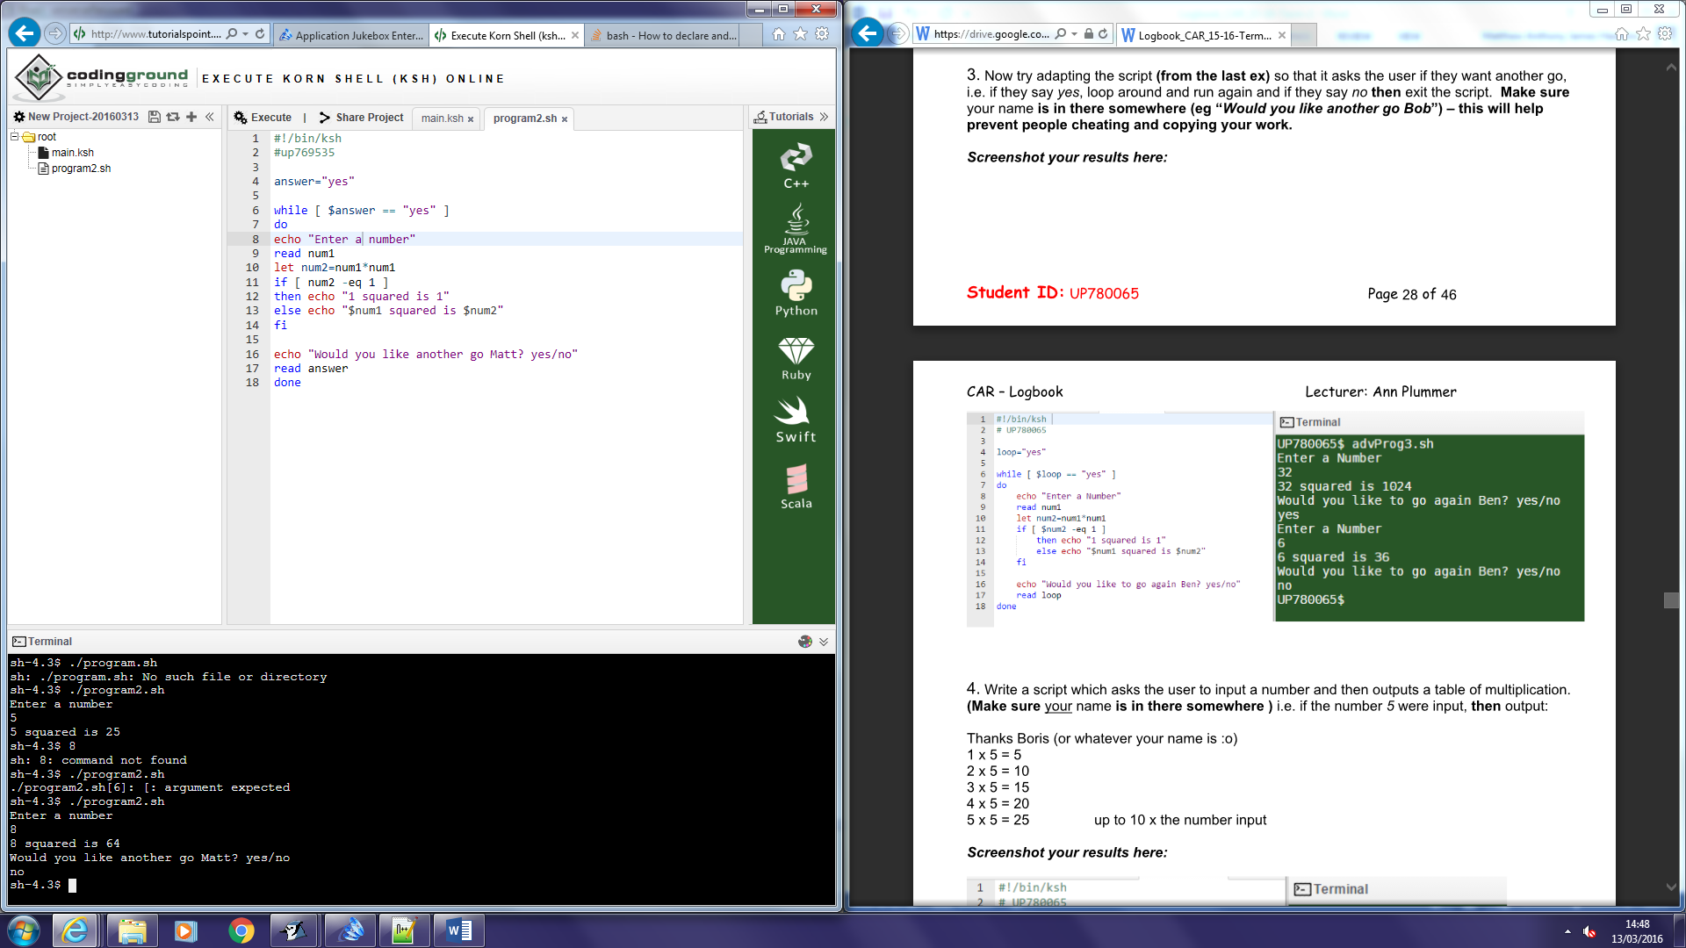

4. Write a script which asks the user to input a number and then outputs a table of multiplication. **(Make sure** your name **is in there somewhere )** i.e. if the number *5* were input, **then** output:

Thanks Boris (or whatever your name is :o)

1 x 5 = 5

2 x 5 = 10

3 x 5 = 15

4 x 5 = 20

5 x 5 = 25 up to 10 x the number input

***Screenshot your results here:***

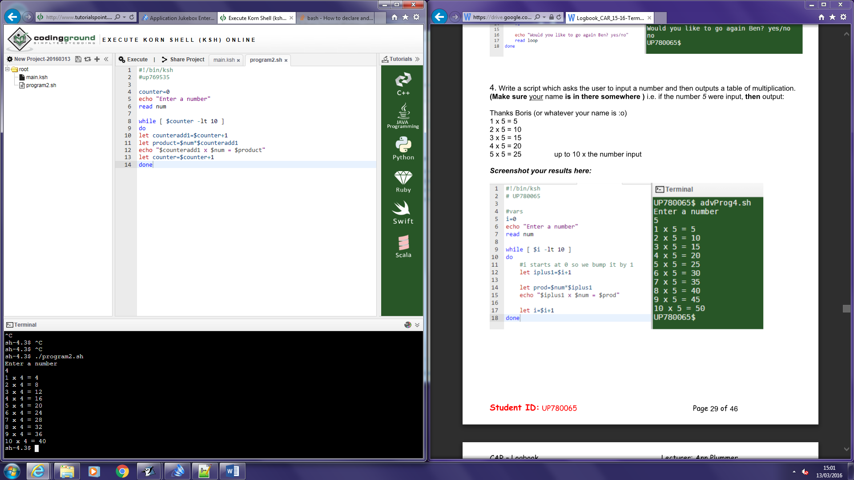

# Topic: Memory Organization ex's 1 - 2 (term 2)

This is a very popular area for exam questions, so I'll leave it up to you how thorough you are with these exercises …. For BOTH of these exercises, **make sure** your name **is in there somewhere (eg write your name on the circuit) – this will help prevent people cheating and copying your work.**

**Mem org Ex 1**

In your logbook:

* Create your own diagram to show how the various components interact on a modern motherboard. You should have a minimum of CPU, IO devices, memory, cache, storage, a bus or two :o), short notes on each component. CPU: Central processing unit. Takes instructions and performs processes on data thousands of times a second.

Matthew Hawkins

Cache: Fast type of memory that sits between RAM and the CPU. Acts as a temporary storage for the CPU to allow it to perform calculations quicker

RAM: Also known as main memory, software applications use this is a temporary storage during use. RAM loses its data once the system is shutdown.

ROM: Another form of memory, usually used for firmware e.g. software that doesn’t need to be changed often (bios etc). ROM keeps its data even after being switched off.

Storage: Usually a hard disk drive, contains a large storage to allow the user to save documents and files to the system without worrying about losing them when the system is shutdown.

IO connections: The IO ports are a variety of ports that allow external devices to connect to the motherboard, e.g. monitor, mouse, keyboard etc.

* List some typical sizes and speeds of your components in a modern machine.
* Processor **3.40GHz**
* HDD storage Size: **1TB Speed: 7200RPM**
* RAM Size: **DDR3** **4GB Speed: 1600MHz**
* **L2 1MB, L3 8MB Cache**
* **Bus Transfer Rate 5,000 MT/s (CPU)**
* State your sources as a mini bibliography.
  + Processor speed - Source - <http://ark.intel.com/products/75122/Intel-Core-i7-4770-Processor-8M-Cache-up-to-3_90-GHz>
  + Hard drive - Source - <http://stablecomputer.com/western-digital-1tb-blue-wd10ezex-review/>
  + RAM – Source <http://www.amazon.co.uk/Kingston-KVR16N11S8-Non-ECC-240-Pin-Memory/dp/B008CP5QR2/ref=sr_1_10?ie=UTF8&qid=1456079608&sr=8-10&keywords=RAM>
  + Cache - Source - <http://cpuboss.com/cpu/Intel-Core-i7-4770>
  + Bus - Source - <http://cpuboss.com/cpu/Intel-Core-i7-4770>
* Get your practical tutor to check and sign off.

**Mem org Ex 2**

In your logbook:

* In your **own words**, list the different sorts of RAM and for each, state:
* Where it lives in the computer system,
* What it's used for,
* Common sizes for modern versions.
* Include RAM, SRAM, DRAM (+ a few variations)
* State your sources as a mini bibliography.
* Get your practical tutor to check and sign off.

The main types of RAM consist of:

1. SRAM
2. DRAM

SRAM

* Usually used in registers or cache
* To allow really fast access to the processor that RAM and other types of memory can’t cope with
* For cache around 1-8MB

DRAM

* Main memory, a large chip that connects into the motherboard
* Used to store temporary data for applications
* 2-16GB (depending on the machines uses)
* DRAM consists of different versions such as DDR1, DDR2, DDR3 etc. generally the higher the number the newer the RAM is and therefore the more efficient however DDR5 is used in Graphics Cards and has been used for a while.

Sources

<http://www.eeherald.com/section/design-guide/esmod15.html>

<http://cpuboss.com/cpu/Intel-Core-i7-4770>

# Topic: Memory Organization ex 3 (term 2)

**Make sure** your name **is in here somewhere – this will help prevent people cheating and copying your work.**

* In your own words, explain what MODERN cache is, what it's made from, where it lives in the computer system, its size etc.

Cache is a type of memory that is located (usually) inside the CPU. It acts as a sort of pocket for the processor to get data quickly when performing calculations. Cache is made up of small chunks of mirrored main memory. Due to it being a part of the CPU it is limited to how large it can be and there are several types of sub-levels with different amounts of memory and speeds. The levels of cache, speeds and sizes can vary on the processor, generally there is at least Level 1 and Level 2 cache but there can be more levels. Level 1 cache has an average size of around 16KB for data, 16KB for instruction and both with speeds of 5ns (nanoseconds). Level 2 has an average size of around 512KB and a speed of 20ns.

* Create your own diagram of the Fetch-Execute cycle and explain cache's place in this.



* State your sources as a mini bibliography. Here are some sources to start you off:
  + <http://courses.cs.vt.edu/csonline/MachineArchitecture/Lessons/CPU/sumprogram.html>
  + <http://www.itrackls.co.uk/p7_cssexpress/pp/intro1.html>

Sources

* + <http://www.bottomupcs.com/memory.xhtml>
  + <https://www.scss.tcd.ie/Jeremy.Jones/CS3021/5%20caches.pdf>
* Get your practical tutor to check.

**Explain in your own words what expansion slots and cards are for in the computer. Create a simple diagram below to illustrate.**

Expansion slots allow the addition of hardware to a computer. There are many different types of slots, one of the most broadly used being PCI due to its flexibility. Expansion cards are the devices that can connect into these slots, for example graphics cards, sound cards, network cards etc.



* Get your practical tutor to check and sign off.

# Topic: Review Qs for Operating Systems (term 2)

1.

Why don’t Maclaren use a general purpose OS, such as Windows 10 as the operating system for their car engine management systems?

* It wouldn’t be able to handle their needs
* It would contain many pointless applications that they wouldn’t need making the system run slower
* Using a commonly used operating system may be less secure than a bespoke system

2.

In your own words, describe the two main things that an operating system does.

* Manages hardware and software resources including the resources of the processor, storage and memory.
* Provides a go-between for hardware and software applications so that software can run on hardware without having to know too much about it, i.e. less work for programmers creating application programs.

3.

Why do some gadgets only need to be single-tasking?

For example a printer, if it took two tasks at the same time then would end up with a mess of two documents printed together. On the other hand you might want to play a 2-player game on a keyboard, in this case the keyboard needs to be able to take more than 1 input/task at a time.

4.

Where in the system is the bootstrap loader stored?

* In EPROM, ROM or another form of non-volatile memory (memory that keeps its data upon shutdown)

5.

List some things the operating system lets you do (with short notes). Aim for 300 to 400 words (an example follows to start you off):

Overall an operating system manages the resources of the system and allows a connection between the applications and hardware, this means that developing programs becomes easier for developers as they can all work off a base. The operating system also acts as interconnection between the user and machine code to provide a readable and understandable platform for the user without the user having to worry about how the machine works.

**File management:**

Manage the file hierarchy system to allow users and programs to access folders and documents as well as read, write and execute them.

**Process management:**

Manages processes and the resources for each process using various algorithms. Prevents processes from interacting with each other.

**Resource management:**

Manages CPU and memory resources so that they are shared evenly throughout the system and so that programs that need more resources get them and those that do not need as much use less.

**I/O management:**  
Searches for new hardware devices that are added which includes hardware devices such as mouse, keyboard, hard drives etc. Also makes sure that lots of different devices can be handled at the same time as well as allowing the correct number of inputs into each device i.e. 1 input for a printer but 2 or more for a keyboard.

**Network management:**

Automatically searches for known networks and connects to them as well as connects to other computers on the same network. Allows seem-less communication with other devices.

**Error handling:**

Checks for error handlers and reports messages to screen for the user e.g. “Printer has run out of paper” or “BSOD A hardware device has failed”. Error handling includes detection, recovery and warnings.

# Topic: Memory Management and Virtual Memory (term 2)

Read <http://computer.howstuffworks.com/computer-memory2.htm> – go through page by page (you may need to do some extra research for some of the Q's) and answer the following questions (this is exam practise! You WILL get some of these Q’s in your exam) :

1.

**(D)**

**(C)**

**(B)**

**(A)**

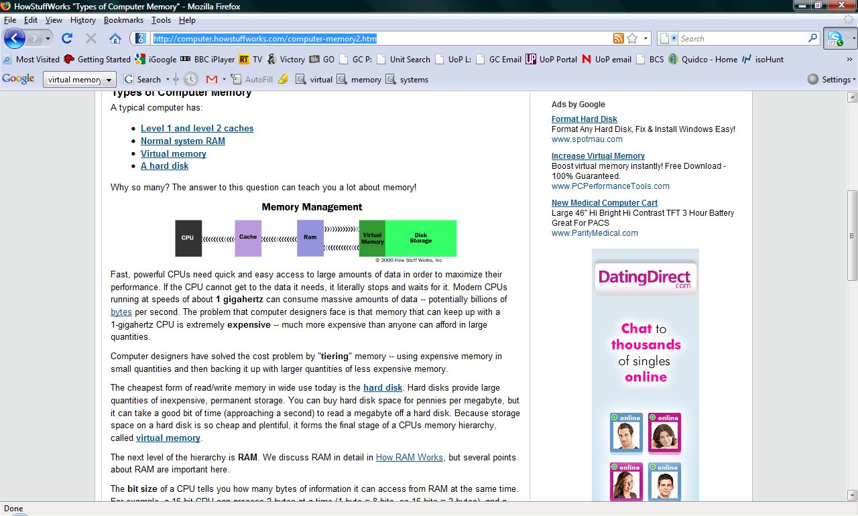

Drag to Label the memory types above

A) Fastest, most expensive, smallest to D) Slowest, cheapest, largest

2. A computer's system RAM alone is not fast enough to match the speed of the CPU. That is why you need **cache**

3. *(select the correct response)*

Latency speeds up the CPU's access to memory **True/False**

**False**

*4. (select the correct response)*

*Burst mode* means that: **C**

a) The CPU is swapping data in and out of cache so it has become inefficient.

b) The cache runs in small bursts to conserve energy.

**c) The CPU assumes that data access has spatial locality and so will keep dipping into the same area of memory.**

d) The computer must utilize pipeline architecture.

e) Reading consecutive bits of memory will take considerably longer, so needs to be undertaken in short bursts.

5. *(select the correct response)*

Pipelining minimizes the effect of latency because it only allows one thing at a time to take place and reduces the strain on the CPU. **True/False**

**True**

6. You have a 100 MHz system and you plug in memory designed to work at 200 MHz.

What speed will your system work at? **100 MHz**

7. On the following diagram, place

(A) on the fastest memory

(B) on the slowest memory

(C) on the memory that contains the boot section of the operating system

(D) on DRAM

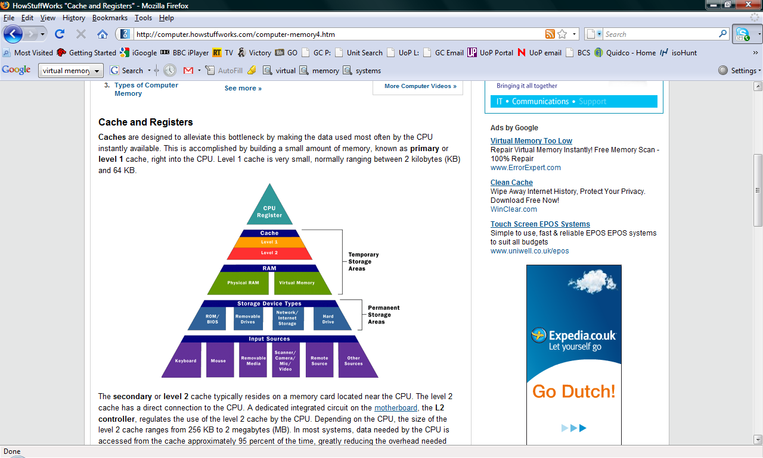(E) on SRAM

**(A)**

**(E)**

**(D)**

**(B)**

**(C)**

8. *(select the correct response)*

What kind of computer memory is both static and nonvolatile? ROM

RAM  
**ROM**  
Cache memory

9. *(select the correct response)*

Where does most data go first within a computer's memory hierarchy? RAM

**RAM**  
ROM  
BIOS

10. *(select the correct response)*  What does BIOS stand for? Basic input/output system

Biological Internet operating system  
Binary inner/outer stages  
**Basic input/output system**

11. *(select the correct response)*  When your computer's speed begins to drop, which element of memory is likely overtaxed? RAM

**RAM**  
ROM  
Flash memory

12. *(select the correct response)*  What is a clock cycle? The CPU's processing speed

The accuracy of a computer's internal clock compared to an external one  
**The CPU's processing speed**  
The amount of time it takes for a computer to recover something from memory after booting up

13. *(select the correct response)*  What is a memory cache? A temporary memory storage device that keeps certain data available for quick reference

The amount of memory your computer has on hand for any particular task  
An outdated memory storage device  
**A temporary memory storage device that keeps certain data available for quick reference**

14. *(select the correct response)*  In the world of computers, what is bus width? The number of bits that can be sent to a CPU simultaneously

The size of the vehicle used to ship the computer  
The number of pins in a computer port  
**The number of bits that can be sent to a CPU simultaneously**

15. *(select the correct response)*  What is latency? The gap between a processor's speed and a computer's bus speed.

The number of clock cycles needed to read a particular bit of information.  
**The gap between a processor's speed and a computer's bus speed.**  
Anything that causes a computer memory crash.

16. *(select the correct response)*

Which kind of computer memory is the first to activate when you turn on your computer? ROM

RAM  
**ROM**  
BIOS

17. *(select the correct response)*

How does virtual memory free up RAM? It looks for data in RAM that hasn't been used much, copies that data to the hard drive and frees up RAM for other processes.

It partitions the computer's operating system, freeing up RAM in the process.  
**It looks for data in RAM that hasn't been used much, copies that data to the hard drive and frees up RAM for other processes.**  
It converts other kinds of memory into RAM temporarily on an as-needed basis.

18. *(select the correct response)*

Thrashing (in the world of computer memory) means: Overclocking the system to increase its speed

**Overclocking the system to increase its speed**

The operating system has to constantly swap information back and forth between RAM and the hard disk

Having to thump the computer's case when the fan becomes too noisy

A virus has infected the BIOS and is causing the CPU to cycle endlessly

There is no such terminology

19. *(select the correct response)*

What sets static RAM apart from dynamic RAM? Static RAM is faster than dynamic RAM.

Dynamic RAM is faster than static RAM.  
**Static RAM is faster than dynamic RAM.**  
There isn't much of a difference between static and dynamic RAM.

20. *(select the correct response)*

What does the method known as *parity* do? Checks for errors

Processes bits and bytes  
**Checks for errors**  
Deletes memory

# Topic: File Systems ex's 1 - 2 (term 2)

This is a very popular area for exam questions, so I'll leave it up to you how thorough you are with these exercises ….

Again, as with everything in your logbook, customize your answers with **your name** or id to help prevent others plagiarising your work.

**File Systems Ex 1**

In your logbook:

* In *your own words* and in 1 to 2 sentences, define what a computer file is.

A computer file is form of information storage that can be accessed from and changed by software and applications. There are different types of files used for different purposes and to store different information.

* List at least 8 typical filetypes (do not choose any from Ex 2) and give their extensions and uses (eg .doc, etc)

|  |  |  |
| --- | --- | --- |
| File type | Extension | Uses |
| HyperText Markup Language | .html | Website layout |
| Graphic Interchange Format | .gif | Still and animated images |
| Plain Text File | .txt | Basic text file |
| Zip File | .zip | Compresses directory file size |
| Microsoft Word Document File | .doc | Different types of documents, allows formatting of text, graphs, images etc. |
| JPEG | .jpg, jpeg | Photographs and high quality images |
| Cascading Style Sheets File | .css | Website styling |
| MP3 File | .mp3 | Audio media |

**File Systems Ex 2**

In your logbook, answer the following:

* What is a DOS .BAT file? What is it used for?

A DOS batch file is a text file that contains a variety of commands that allow the system to perform a task or set of tasks. They can shorten processes that take multiply commands by using one command instead.

* Compare a .BAT file to a Unix Shellscript

The two are essentially the same thing but for two different operating systems. Each has their own syntax for script programming. Some examples of which can be found here - <http://www.xoogu.com/2012/differences-between-windows-batch-and-linux-bash-shell-script-syntax/>

* Explain what at least 3 different graphics file formats are and how they compare to each other – what are the specific uses for each of them?

|  |  |  |  |
| --- | --- | --- | --- |
| Format | Typical Use(s) | Features | Limitations |
| GIF | Widely used on the web due to its wide support and portability. Well suited for simple images such as graphics and logos with solid areas of colour. | Small file sizes, simple images, supports animations. | Due to the colour palette limitations GIFs are unsuitable for reproducing colour photographs along with other images with continuous colour. Can give a blocky quality to images that are animated and therefore reducing the overall visual quality. |
| BMP | Usually used for Printable Images. | Capable of storing 2D complex digital images that are really crisp, high quality graphics but also have really large file sizes. | BMP’s do not resize very well. You can scale them down without loss of clarity and quality but if you try to enlarge the image then it will become pixelated. They also have large file sizes. |
| SVG | Mainly used on the web for scalable graphics. Supported by W3C web standards. | SVG images and their behaviours are defined in XML text files. This means that they can be edited with any text editor. | SVG has a relatively big file size as they are used for more advanced graphics with more detail e.g. shadows etc. |

* Describe Lossy and Lossless compression (v briefly!) and how these affect graphics files.

Lossless compression is a form of compression that focuses on radically reducing the file size of files by deleting and removing parts of the file that are not needed. Usually these are parts of information stored on the file that are duplicated, not needed or that the file can quite simply do without while not removing any files that would other whys reduce the quality.

Lossy is slightly different in the respect that it just decreases the quality to reduce file size and will delete parts of the image that may be important to its overall look. This file compression type, however, can reduce the file size a lot more than lossless.

# Topic: My Formative Test post mortem and Exam Revision (term 2)

* Paste/scan your test into your logbook:

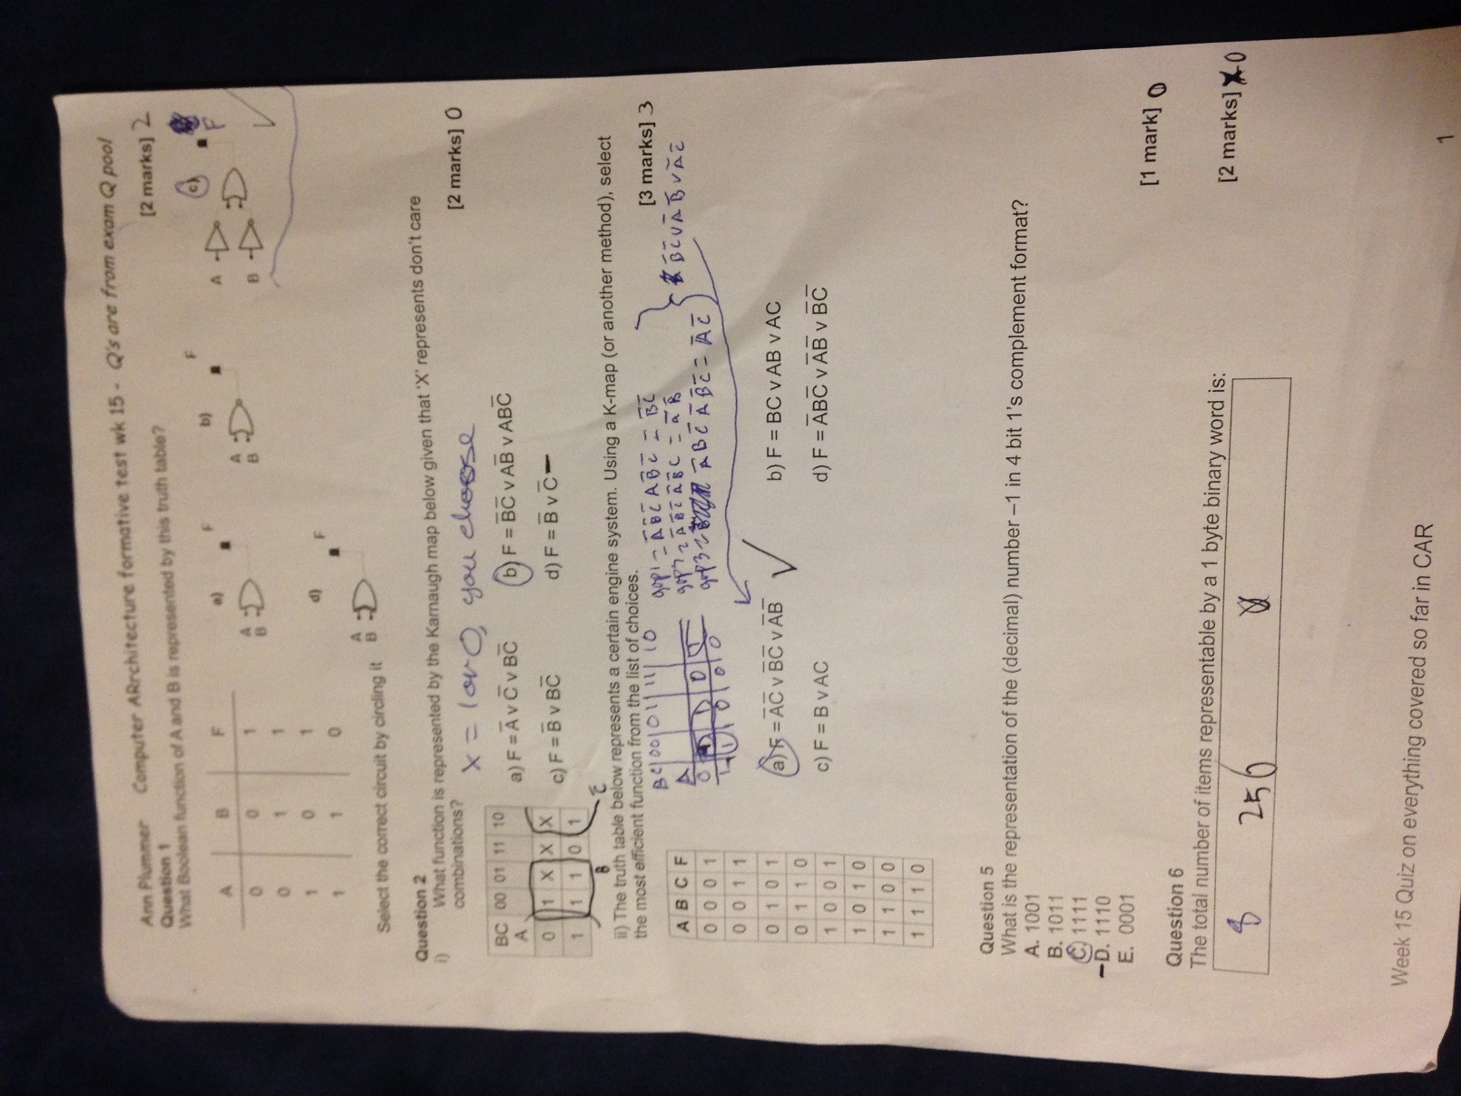

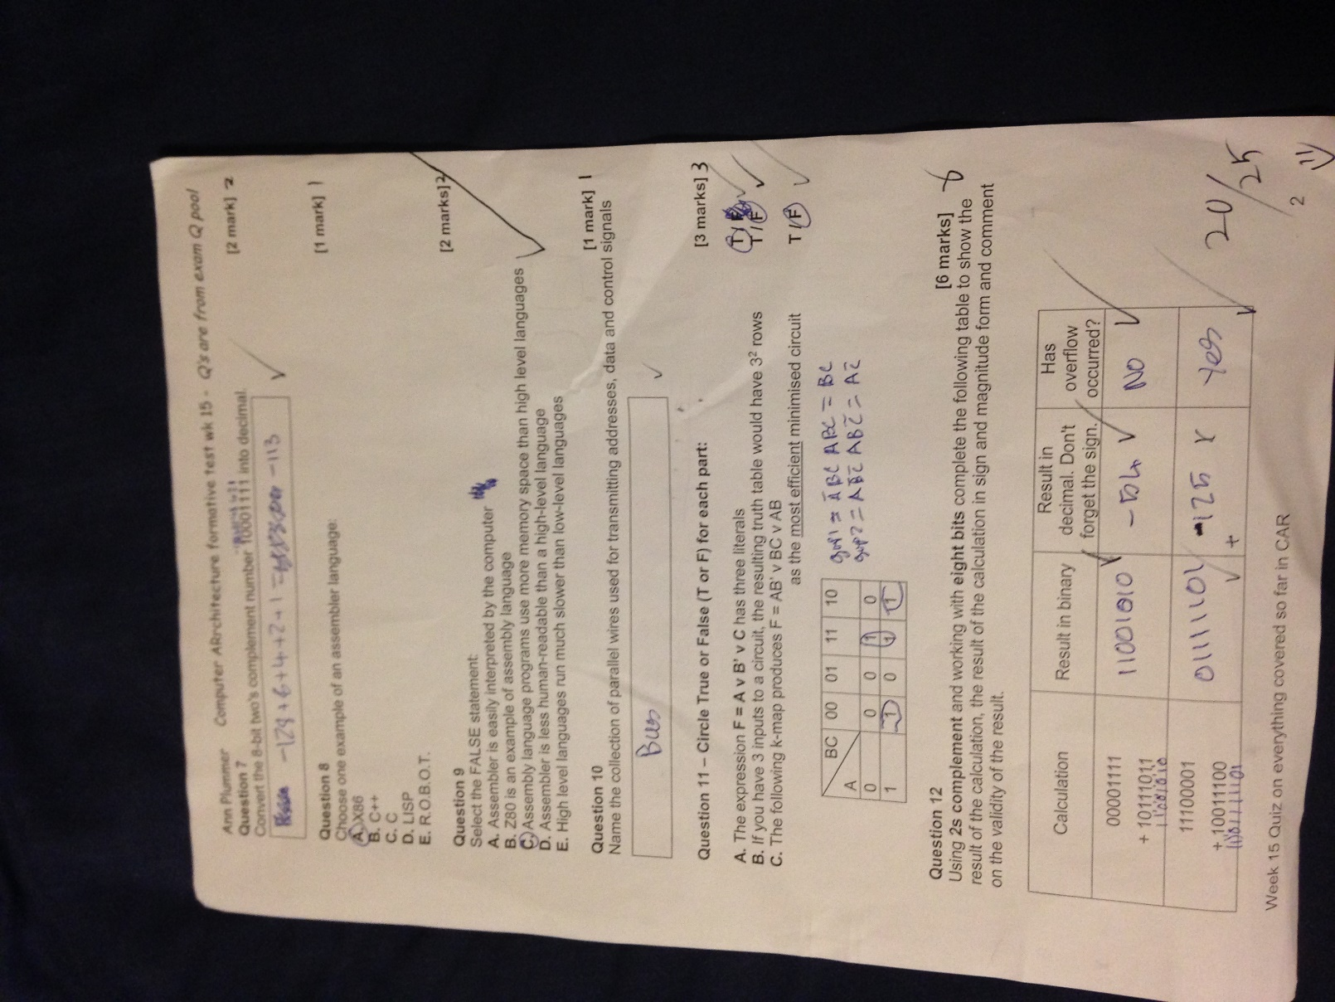

* Carefully scrutinize your formative test.
* Write down your score 20/25

* What would your grade have been? DISTINCTION
* Are you on track for the grade you want in CAR? (0-39% is FAIL, 40%- 59% is PASS, 60%-69% is MERIT, 70%-100% is DISTINCTION)
* Happy? Great – relax, you don't have much catch-up to do (unless you're easily pleased)
* Not so happy? Write down the areas you struggled most with and plan your

**EXAM REVISION:**

* **‘X’ don’t care combinations in K-maps where X can be 1 or 0 based on the best choice at the time**
* **Difference between converting numbers into 1 and 2s compliment, especially negative numbers**
* **Make general flashcards based on last terms logbook and this tests questions, as well as any other material for the unit**
* **Get your final outstanding signoffs while there are still remaining practical sessions – without them you will fail CAR**

# Bibliography

Linux commands - <http://mally.stanford.edu/~sr/computing/basic-unix.html>

Linux commands - <http://www-users.york.ac.uk/~hcb1/unix20.html>

Wildcard information - <http://www.linfo.org/wildcard.html>

# Checklist

Have you attempted EVERY exercise in each term?

Have you obtained the minimum number of signoffs in your receipt sheet each term?

Have you passed your logbook? (it is not possible to retake this)